Table of Contents

Summary 2

Methodology 4

Definitions 4

Nostalgia: A symptom of homesickness 6

Unpacking the paradox of nostalgia 6

What is home? 7

Expression of desires for the present 9

Modernity: a long way from home 9

Loneliness 11

Time pressure 16

Nostalgia: a vehicle for creating a home away from home 20

Value for producers and consumers 21

Heuristics for using nostalgia as an approach to experience design 22

Existing heuristics 23

Goals for nostalgia in design 23

Approaches for past experience 23

Means of evoking a nostalgic experience 24

Proposed Metaheuristic 25

Critique of Existing Heuristics 26

An Alternative Heuristic 27

Workshop for embedding nostalgia in experience design 31

Workshop activities 31

Themes generated through conversation 35

Ideas for experiencing food differently 38

Feedback and Reflection 40

Nostalgia as a design approach 40

Framing of workshop 41

Workshop activities and process 42

Overall impact 43

Ethics of nostalgia 43

Conclusion 45

Social Implications 46

Next steps 46

Game: “Thing from the past” 47

Bibliography 49

# **Summary**

At the heart of this paper is an exploration of the interaction between two shifts in society. On one hand there is a fast-moving society that is experiencing increasing rates of disruption due to globalization and communication technologies. On the other, there is a culture that is increasingly influenced by nostalgia for the ‘good old days.' The relationship between the two are described in detail, along with ways that designers, who are active participants in shaping culture and people’s individual experiences, can make sense of nostalgia and the potential for it to be used in experience design.

The research starts by defining nostalgia as a longing for home -- feelings of intimacy and absence from time pressures. The paradoxical definition of nostalgia is unpacked as a three-step-sequence that involves displacement from home, reaching for home, and recreating a sense of home in the present

We are nostalgic for a deeper sense of connectedness and a slower sense of time because, despite being at the height of affluence throughout history, modernization created an environment where people are lonelier and more pressed for time– which have significant implications for well-being -- than people living in societies that are not as affluent or have not adopted the modern way of living; hence an increase in depression and general disaffection is observed in modern societies.

These disaffections are caused by things that characterize modernity. Examples include adoption of technologies that reduce the need for inter-reliance and seeing time as money that motivates us to work more. As these characteristics persist into the future, there will be increasing need to foster resilience among people. Nostalgia is a vehicle that can used in experience design to transport positive feelings from the past into the present.

To help designers leverage nostalgia in experience design, three existing heuristics are analyzed and used to construct a metaheuristic. They are then individually critiqued and an alternative heuristic is proposed. The proposed heuristic portrays nostalgia as comprised of cues belonging to four layers: feeling, activity, essence, and world, with feelings being at the center of the experience, and the world on the very outside.

Building on the research and the heuristic, a workshop was developed to guide designers through a process of discovering positive experiences in the past and its associated feelings that we miss today, and retrieve those feelings through designing nostalgic experiences. The workshop was piloted with six designers around improving the experience of eating by tapping into nostalgia for hunter-gatherers. Ten nostalgia design principles were extracted from the conversation and decontextualized for applying in any context. Feedback gathered from participants about the design of the workshop are turned into design principles for the next iteration.

To disseminate the findings and further develop this approach, the nostalgic design principles developed through the workshop will be used to prototype a card game whose format resembles Stuart Candy’s Thing from the Future. Designers can play this game to think about how to design nostalgic experiences across different media and contexts. The next steps also include reaching out to stakeholders in private, public, and academia to spark a conversation around using nostalgia in design.

# Methodology

**Literature review**

An extensive literature review was conducted to understand the relationship between affluence and well-being. Topics included the current state of well-being, factors that contribute to well-being (or a lack of), how those factors were influenced in both distant and recent history, and well-being in hunter-gatherer communities for contrast. A literature review was also conducted on the current state of nostalgia from a sociological perspective, the psychology of nostalgia, how nostalgia affects consumer attitudes and consumption behaviors,

**Expert interviews**

Interviews were conducted with experts in a variety of fields to get different perspectives on the implications of nostalgia in design. Experts interviews included a psychotherapist, psychology researcher, researcher on Amish culture, and designers specializing in industrial design, ritual design, and design thinking.

**Systems mapping**

**Systems mapping was used to illustrate the self-reinforcing relationships between societal factors that contribute to the overall acceleration of pace of life, and the resulting feeling of time famine.**

**Prototyping**

After developing a way of making sense of nostalgia and a process that designers can use to create nostalgic experiences, a workshop was held with six designers to these concepts over the course of 1.5 hours. Feedback was gathered from participants in the workshop and were used to inform the development of the next iteration.

# **Definitions**

**Experience design**

Experience design is defined as the “practice of designing products, processes, services, events, omni-channel journeys, and environments with a focus placed on the quality of the user experience and culturally relevant solutions” (Marzano, 2003). A more succinct – but no less ambiguous – way of capturing the essence of experience is Hassenzahl (2010)’s definition, “An experience is a story, emerging from the dialogue of a person with her or his world through action.” Being medium-agnostic, designing an object, service, or environment can all be considered as experience design.

**Designer**

**The word designer in this research is defined broadly to include any individual who partakes in the activity of design – the conception or creation of change of any kind or scale that has an impact on others. This broad definition is used because this research is intended to empower any individual to think about how nostalgia may play into their everyday work. Innovator, entrepreneur, engineer, urban planner can all be considered as “designers” in this research.**

**Modern / Modernity / modernization**

**For the purposes of this project, the word “modern” and its variations refer to modern Western society and its values. It is** loosely defined as **a conglomeration of** urbanization, industrialization, technological advancement, secularization, consumerism, and westernization. It is more related to a culture than a specific time. I.e. Hunter-gather and Amish communities co-exist with “modern” societies today, albeit in different parts of the world.

# **Nostalgia: A symptom of homesickness**

The word nostalgia comes from the Greek words "nostos,” which means "homecoming,’ and "altos" - "grief and suffering." Home – in a broader sense – is not a thing, but a sense of familiarity and intimacy with your surroundings. TED speaker Pico Iyer in his interview talking about his 2013 TED Talk “What is home?” said “for more and more of us, home has really less to do with a piece of soil than you could say with a piece of soul.”

Today, signs of nostalgia are flourishing in the modern Western society. From the widespread adoption of Instagram, popularized by its vintage filters, to the spread of artisan coffee shops, to the resurgence of vinyl records, to the engagement created by Facebook memories. Byom (2002) observed “[Nostalgia] permeates twentieth-century popular culture.” At the turn of the Millennium, comic and critic George Carlin ( (1998), cited in (Lowenthal, 1985)) moaned “America has no now. Our culture is composed of sequels, reruns, remakes, revivals, reissues, … recreations, re-enactments, adaptations, anniversaries, memorabilia, oldies radio, and nostalgia record collections.”

Nostalgia was initially coined to describe a medical disease in the 1600s by the Swiss physician Johannes Hofer, to refer to the adverse psychological and physiological symptoms displayed by Swiss mercenaries spending time away from home (Routledge, et al., 2011). But unlike a medical disease, “progress did not cure nostalgia but exacerbated it,” noted (Boym, 2002). It is no wonder nostalgia permeates our culture, as it is thought of as a response to the characteristics of modern life. As Byom (2002) observed, “nostalgia inevitably reappears as a defense mechanism in a time of accelerated rhythms of life and historical upheavals.” Contemporary researchers view nostalgia as “a valid fundamental human experience which crosses cultural, social, economic and age-related boundaries” (Routledge, et al., 2011).

## Unpacking the paradox of nostalgia

“The study of nostalgia does not belong to any specific discipline: it frustrates psychologists, sociologists, literary theorists and philosophers, even computer scientists” (Boym, 2002)

It’s not easy to define nostalgia; as Howland ( (Howland, 1962), Cited in (Wilson J. L., 2005)) describes nostalgia as “a confusing emotion, full of paradoxes.” However, portrayals of nostalgia reveal a pattern of juxtaposition between positive and the negative emotions. Howland ( (1962),, Cited in (Wilson J. L., 2005)) said “It is painful yet in the pain there may be a peculiar sweetness defying description.” Johnson-Laird and Oatley ( (1989, cited in (Wildschut, Sedikides, Arndt, & Routledge, 2006)) defined nostalgiaas positive emotion with tones of loss. Mills and Coleman ( (1994), cited in Wilson, 2005) “the bittersweet recall of past emotional events.”

The bittersweet emotion of nostalgia can be experienced as a three-part sequence:

1. **Displacement from home (bitter)**

* Byom’s description of nostalgia as “an ache of temporal distance and displacement” relates nostalgia to a kind of suffering from the passing of time, which portrays that nostalgia as a response to the loss of something good from a previous time. This is consistent with research that found negative mood as a trigger for nostalgia (2006).

1. **Reaching into the past in search of home**
   * The widely quoted Herb Cain saying of “Nostalgia is memory with the pain removed” suggests an act of remembering positive things from the past. Wilson also speaks about nostalgia as a positive place that can be reached, “When experiencing nostalgia, we might feel that we are getting close to something fundamental, ‘good,’ a foundation, or a purpose.”
2. **Creating a sense of home in the present (sweet)**
   * Research (Wildschut, Sedikides, Arndt, & Routledge, 2006) has shown that when people reflect on these positive feelings from the past, they feel more positive in the present. Given its complex and positive nature, some researchers (Wildschut, Sedikides, Arndt, & Routledge, 2006) believe nostalgia should be in a league with other positive emotions such as love (Izard, 1977), pride (Lewis, 1993) and joy (Ellsworth & Smith, 1988).

## What is home?

**Home is a feeling**

Lowenthal (1985) noted “nostalgia is often for past thoughts rather than past things.” Hirsch (1992)) observed that “nostalgia… does not relate to a specific memory, but rather to an emotional state.” And Wilson (2005) sees nostalgia not as a true desire to go back in time but “a longing to recapture a mood or spirit of a previous time.” These scholars have in their writings casted nostalgia not as a desire for something concreate that can be articulated through words but a longing for something that can only be intuitively felt – a mood, a spirit, thoughts, or emotions of a previous time.

**Home is a feeling of intimacy**

“To feel at home is to know that things are in their places and so are you; it is a state of mind that doesn’t depend on an actual location. The object of longing, then, is not really a place called home but this sense of intimacy with the world.”  
(Wilson J. L., 2005)

Wildschut et. al. (2006) found negative mood – loneliness in particular – is likely to trigger nostalgia. When people are asked to write about nostalgic experiences, the narratives typically “revolved around interactions with important others,” which helps a person feel more connected (Wildschut, Sedikides, Arndt, & Routledge, 2006). Further, thinking about a nostalgic event (compared to an ordinary event) resulted in greater feelings of being ‘‘loved” and ‘‘protected,” lower feelings of attachment anxiety and avoidance, and greater feelings of interpersonal competence and support ( (Wildschut, Sedikides, Arndt, & Routledge, 2006), (Zhou, Sedikides, Wildschut, & Gao, 2008)

**Home is a feeling of the absence of time pressure**

Contemporary nostalgia is not so much about the past as about the vanishing present.  
 (Boym, 2002)

Through a review of social-psychological explanations for the nostalgia craze in contemporary America, Cameron and Gatewood (1994) identified nostalgia as a “slowing mechanism,” which they explained as “a psychological adaptation to circumstances of rapid culture change during which individuals fear becoming obsolete.” Byom (2002) wrote, “The past of nostalgia, to paraphrase William Faulkner, is not even past. It could be merely better time, or slower time—time out of time, not encumbered by appointment books.”

Drawn by the opportunity to glimpse "a better time,” more than 19 million tourists visit Amish Country each year. Susan Trollinger’s analysis (2012) of the “tourism of nostalgia” in Amish Country revealed that time pressure is one of the reasons why people visit the Amish. “When they perform the highly idealized and, for many, lost tradition of eating a meal with their entire family,” the performance suggests to tourists themselves that since the food took time to prepare, and to consume, they have enough time (Trollinger, 2012).

## Expression of desires for the present

Contrary to the common view of nostalgia as a desire to return to the past, numerous scholars have looked beyond nostalgia’s face value and recognized it as an indicator of a deeper issue at stake. Wilson quotes Kimberly Smith (2000) “[W]e should recognize that remembering positive aspects of the past does not necessarily indicate a desire to return there. Remembering the past should instead be seen as a way to express valid desires and concerns about the present – in… relationship to the past.” As political theorist Steve Chilton (2002) suggested, “nostalgia could be very valuable in helping us figure out what people want – their positive goals – apart from conflict and hostility.”

The strong influence of nostalgia on our culture today, and the themes of nostalgia (intimacy and freedom from time pressure) are indicators of our concerns in the present: a lack of intimacy and chronic time pressure.

# Modernity: a long way from home

“When you live in a village, naturally, you live close to nature. And the natural world around affects the way you are. It creates extended family. It creates shared community. And it creates a sense of belonging to something. And I think that a lot of the anxiety disorders and depression that we see in the world are actually an undiagnosed **homesickness** for a sense of belonging.” - (Varty, 2016)

In our time, depression is on the rise. Two large studies with a sample of roughly 9,500 and 2,200 participants respectively showed a ten-fold increase in risk for depression for those born in the 1970s versus those born in the 1920s (Seligman, 1990). More recently, four surveys of 6.9 million Americans found substantially higher levels of depressive symptoms in the 2000s-2010s compared to the 1980s-1990s, and were twice as likely to have seen a professional for mental issues (Twenge, 2015)

America is not alone in experiencing what Martin Seligman -- former president of the American Psychological Association (2015), and the 31st most cited Psychologist in the 20th century (Haggbloom, et al., 2002) -- calls “an epidemic of depression in every industrialized nation in the world.” Increased rates of depression were found among the Swedish ( (Hagnell, 1989), (Hagnell, L, Otterbeck, & Rorsman, 1994)) The Chinese (Lee, et al., 2007) Ontarians ( (Centre for Addiction and Mental Health, 2016)). Even in Denmark (Andersen, Thielen, Per, Nygaard, & Diderichsen, 2011), the happiest country on Earth according to the World Happiness Report (Helliwell, Layard, & Sachs, 2013),

While there is strong evidence to supporting the over-diagnosis of mental health disorders (Mojtabai, 2013), it is unlikely that over diagnosis can account for the ten-fold increase in diagnosis in the US over such a short period of time, and suffice as the only explanation for increasing rates of mental health disorders around the world (Seligman, 1990).

As affluence and urbanization rise in a society, rates of depression tend to go up rather than down (Nesse & Williams, 1994) (Hidaka, 2012). In one population survey conducted on a sample of 3012 Mexican immigrants into the US and US-born adults of Mexican origin, it was found that greater social assimilation into the US increases rates of mental deterioration (Vega, Sribney, Aguilar-Gaxiola, & Kolody, 2004), despite increased socioeconomic status of living in the US.

Among the myriad of factors that could have led to this paradoxical phenomenon, two societal trends stand out: increased reports of loneliness and increased feeling of time pressure. If nostalgia can indeed by seen as a signal to understand deeper concerns about society, then the most common themes of nostalgia – intimacy and a slower time – point to loneliness and time pressure as people’s biggest concerns. This is supported by researcher findings that highlight both the impact of loneliness and time pressure on our well-being and their increasing prevalence and intensity in society.

By investigating how adoption of tools, behaviors and environments impacted our sense of connection with others and perception of time, we can begin to make sense of the root causes that led up to our lack of intimacy and the time pressure we experience today. This understanding can inform the design of nostalgic experiences that go beyond remembering the feeling of intimacy and a slower pace of life to recreating those feelings in the present.

## Loneliness

One of the most telling studies on human happiness is the Harvard Grant Study. It is a 75-year longitudinal study that began with 268 Harvard undergraduates from the classes of 1939–1944, and continues to this day with the remaining few who are still alive and their thousands of children. The director of this study today, Robert Waldiner, said in his 2015 TED Talk: “The clearest message that we get from this 75-year study is this: Good relationships keep us happier and healthier. Period.”

Today, more Canadians than ever live alone, and almost one-quarter describe themselves as lonely. In the United States, two studies showed that 40 per cent of people say they are lonely, a figure that has doubled in 30 years (Renzetti, 2013). Loneliness has been linked to depression, anxiety, interpersonal hostility, increased vulnerability to health problems, and even to suicide (Renzetti, 2013).

From 1985 to 2004, the percentage of people who said there was no one with whom they discussed important matters tripled, to 25%; the same study found that overall, Americans had one-third fewer friends and confidants than they did two decades ago (McPherson, Smith-Lovin, & Brashears, 2006). A group called Lifeboat, which describes itself as a movement “celebrating deep friendships,” recently conducted a full-scale study on the state of friendship in the United States, and found only a quarter of adults are truly satisfied with their friendships. ( (Lifeboat, 2013), cited in (Leberecht, 2015))

“Solitude can be lovely. Crowded parties can be agony.” Marche (2012) wrote in an article in The Atlantic. Loneliness and being alone are not the same thing. The solution to loneliness is not merely being in the presence of other people, but a deeper sense of connectedness. As writer Richard Bach says, “The opposite of loneliness is not togetherness, It's intimacy.” Today, Bensman and Lilienfeld (1979) have stressed the growing concern to achieve intimacy in modern societies: “the demand for intimacy persists to the point where it is virtually compulsive.” The lack of intimacy in society today can be explained using a variety of perspectives:

**The role of face time**

We are at the most interconnected point in history. Why are people still feeling lonelier than before? John Cacioppo, the world’s leading expert on loneliness, notes that while social media and the internet does not cause loneliness, but how people use them do. “If you use Facebook to increase face-to-face contact, it increases social capital.” Social isolation and depression sets in when internet use replaces more tangible forms of human contact ( (Kraut, et al., 1998), cited in (Cacioppo & Patrick, 2008)). Numerous studies demonstrate that face-to-face contact is the best way to build strong ties that ward off loneliness ( (Kraut, et al., 1998), (Rockmann & Northcraft, 2008)).

“The greater the proportion of face-to-face interactions, the less lonely you are,” quoted Cacioppo in an article for The Atlantic (Marche, 2012). “The greater the proportion of online interactions, the lonelier you are.” Given “One-in-five Americans are online ‘almost constantly’” (Perrin, 2015), it’s hard to imagine the proportion of human contact not taking a hit. The internet has encroached so far into personal relationships that in a recent set of studies where seventy-four participants were asked to engage in a series of 10-minute conversations with each other, the mere presence of a phone nearby, even without anyone checking it, was found to inhibit interpersonal closeness and trust (Przybylski & Weinstein, 2013).

**The role of technology**

**To understand the effects of Industrial Revolution on interpersonal relationships, the agrarian lifestyle that the Amish community works hard to preserve and its effects on warding off loneliness and mental disorders is worth studying.** In a monumental study of 12,500 members of the Old Order Amish of Pennsylvania, depression in Amish communities was found to occurs at one-fifth to one-tenth the rate of depression in Baltimore, New Haven, and St. Louis ((Egeland & Hostetter, 1983), cited in (Seligman, 1990)).

**Above all else, the Amish puts a** premium on spending time together and actively engaging one another, and therefore are **det**ermined to protect a way of life that maximizes a sense of community (Trollinger, Selling the Amish: The Tourism of Nostalgia, 2012)**.** They reject many technologies because **of their tendency to “**push members of their community apart from one another” ( (Umble, 2000) cited in (Trollinger, Selling the Amish: The Tourism of Nostalgia, 2012)). The Amish is right to be concerned, as technology has – in many historical instances – reduced people’s need to develop deeper relationships. When the Great Atlantic and Pacific Tea Company opened its A&P stores, giving Americans self-service access to groceries, customers stopped having relationships with their grocers. When the telephone arrived, people stopped knocking on their neighbors’ doors (Marche, 2012).

The Amish avoid automobiles because the significant amount of effort required to hitch a horse to a buggy and the slow pace of buggy travel encourages people to stay home or, if they do go somewhere, to not go far. Harvesting without an motorized harvester encourages dependence on extended family and friends for help ( (Kraybill, 2001), cited in (Trollinger, 2012)). Likewise, televisions, computers, iPods, and the like are not welcome in Amish homes, because such devices tend to separate individuals from one another (Trollinger, Selling the Amish: The Tourism of Nostalgia, 2012).

**The role of danger**

Humans are wired to feel most connected when they have a sense of “shared fate," the idea that the survival of the individual and the survival of group are one and the same. A shared fate encourages cooperation and keeps competitive drive dormant (Buss, 2000).

Modern society has controlled many of the hostile forces of nature that used to give us a sense of shared fate. The hostile forces that do remain fall under the jurisdiction of faceless institutions like the legal and healthcare system (Buss, 2000). This led to a lack of opportunities for friends to demonstrate commitment to each other’s welfare in times of danger. Evolutionary psychologists Tooby and Cosmides (1996) argues that this lack of “critical assessment events” to be a cause for not knowing who your true friends are, and therefore an absence of a deep sense of connectedness.

Psychologist Charles Fritz (1996) found that disasters thrust people back into a more ancient way of relating, in which mutual suffering and in-group solidarity allowed the kind of intimate connections that individuals find immensely reassuring. Since the first sociologist to observe this improvement in mental health during war (Durkheim, 1897), all subsequent investigations have consistently a decline in suicide rates during times of disaster (Fritz, 1996). This includes the Belfast Riots (Lyons, 1971), both world wars ( (Lester, 1995) cited in (Salid, 2003)), after assassination of John F. Kennedy ((Biller, 1977) cited in (Salid, 2003), after September 11 (Salid, 2003).

During and after disasters, the differences that usually kept people apart – class, income, and race – are temporarily erased, and individuals become valued not by who they are but by what they do for the group (Fritz, 1996). Time and time again disasters unified communities and made them “more just, more egalitarian, and more deliberate fair to individuals,” Pulitzer-winning journalist Junger (2016), who describes these times as “a kind of social utopia that is enormously gratifying to the average person and downright therapeutic to people suffering from mental illness.”

**The role of competition and mass media**

Intimacy is fostered through interdependence. The opposite of interdependence is independence. A need to be interdependent promotes cooperation and intimacy, while a desire to be independent drives competition (Slater, 1970). Being a land of pioneers, pioneer values of independence and self-reliance are upheld in America’s individualistic culture (Weaver, 1999). America and Canada share similar individualistic values, as the two countries scores 91/100 and 81/100 respectively on the individualism dimension Hofstede’s Cultural Dimensions (2016) scale. Individualistic cultures foster competition (Leibbrandt, Gneezy, & Listd, 2013). Hence American society lies near the competitive extreme (Slater, 1970). Cultural values that emphasize competition, individualism and personal success increase the incidence of loneliness (Perlman & Peplau, 1981). Slater (1970) wrote, "The competitive life is a lonely one.”

Mass media – including TV and social media – have accelerated globalization and the intensity of competition (Nesse & Williams, 1994). The more we watch TV, the stronger our competitive aspiration (Bruni & Stanca, 2006). Having­ strong competitive drive not only acts against people’s search for connection, but also reduces people’s satisfaction with life (Stutzer, 2004). Social media have the same effect, as numerous studies ( (Centre for Addiction and Mental Health, 2015), (Kross, et al., 2013), (Lin, et al., 2016)) found a strong link between social media and depression.

**The role of equality**

Inequality intensifies social hierarchies. This intensification drives status competition, and worry regarding one’s relative position in the status hierarchy, thereby bringing about heightened status anxiety (Pickett & Wilkinson, 2010) and pushing people apart. With the top 5 percent claiming over 60 percent of the nation’s wealth, the current inequality of labor income in the United States, as French Economist Thomas Piketty (Piketty, 2013) concludes, "is probably higher than than in any other society at any time in the past, anywhere in the world, including societies in which skill disparities were extremely large." A survey on 165 households with an average net worth of $78 million found that even the wealthiest are insecure about their social status (Wood, 2011). This is precisely why the Amish renders everyone’s appearance the same, with plain clothes sewn at home with inexpensive fabrics that signal economic equality ((Kraybill, 2001), cited in (Trollinger, 2012)).

While all cultures today have different levels of inequality, nearly all of them accept some form of inequality exhibited through hierarchy. Hierarchy became the norm forty-thousand years ago, when humans developed the ability to store food and accumulate possessions (Gray, 2009). Before then, the survival of immediate-return hunter-gatherers, who lived in 20-50 person bands, hinged on a group’s ability to work together, which would be threatened by hierarchical relationships (Gray, 2009). They actively guarded against social hierarchy by enforcing what anthropologist Richard Lee (1988) calls “fierce egalitarianism.” It means that no one has more than anyone else, that everyone’s needs are equally important, and that no one sees himself or herself to be superior to others (Gray, 2009). Failing to share, or having more than someone else is a declaration that one is no longer a member of the band ( (Weissner, 1996), cited in (Gray, 2009)) Immediate-return hunter-gatherers actively use what anthropologists call ‘humility-enforcing’ or ‘leveling’ devices to quell budding expressions of individual superiority ( (Lee R. , 1988), cited in (Gray, 2009)) For example, when a hunter brings a large kill into the camp, everyone rejoices except for the hunter who actually killed the animal (Gray, 2009). Having no more than anyone else sounds preposterous to the average person in any modern society, but it’s the that characterized the majority of human existence (Gray, 2009).

## Time pressure

People in Western societies increasingly self-report heavy time pressure. The proportion of Americans reporting that they always feel rushed rose from 25 percent in 1965 to 35 percent forty years later (Wajcman, 2014). Almost half now also say that they almost never have time on their hands (Wajcman, 2014). In time use studies, people have been found to eat faster, sleep less, and communicate less with our families than previous generations did (Rosa, 2010). They We also tend to multi-task more frequently to save time (Rosa, 2010). A international study (Wiseman, 2007) found people’s walking speeds in 2007 have increased by 10% than in the early 1990s. This is indicative of an increased pace of life, as numerous studies have used walking speed as a proxy for pace of life (Bornstein & Bornstein, The pace of life, 1976) (Bornstein, 1979) (Amato, 1983) (Levine, 1999).

The more people feel they need to accomplish in a given amount of time, the more intense their feeling of time pressure becomes (Rosa, 2010). Time pressure is associated with feelings of stress and can have a negative influence on happiness and life satisfaction. Research has shown that people who often feel pressed for time have lower feelings of emotional wellbeing and more trouble sleeping than people who do not feel pressed for time (Roxburgh, 2004). Consequently, having lower levels of time pressure is better for wellbeing (Canadian Index of Well Being, 2016).

**Role of social change**

Global warfare, technological innovation, rapid obsolescence, radical modernization, massive migration, and increased longevity leave us in ever less familiar surroundings, estranged even from our recent pasts. ‘Every man is a traveler from another time’, said the publisher William Jovanovich, ‘and if the journey is long he ends up as a stranger’ – (Lowenthal, 1985)

The accelerating technological change has directly impacted the pace of social change, which had never been as fast, broad in scope, and disruptive to pre-existing social practices and modes of behavior as it is today (Giddens, 2013). **Technological acceleration drives a**ll kinds of social structures – attitudes, values, fashions and lifestyles, social relations and obligations, groups, classes, social languages as well as forms of practice and habits – to change at ever-increasing rates (Korunka & Hoonakker, 2014). To illustrate, the change in the realms of family and work has accelerated from an intergenerational pace in early modern society to a generational pace in “classical” modernity to an intragenerational pace in late modernity (Rosa, 2010).

|  |  |  |  |
| --- | --- | --- | --- |
|  | Early modernity (agrarian economy) | Classical modernity (industrial economy) | Late modernity (creative economy) |
| Family | Stable family structure over centuries: generational turnover leaving the basic structure intact | Family structure built to last for just a generation: organized around a couple and dispersed upon death | Increasing rates of divorce and remarriage. |
| Jobs | The father’s occupation was inherited by the son, potentially over many generations | Children are free to choose their own occupation, but they generally choose only once in a lifetime. | On average each person has numerous jobs. |

In a society with accelerated rates of social change, individuals feel pressed to keep up with the speed of change they experience in their social and technological world in order to avoid losing out on opportunities and risk becoming obsolete. Keeping up requires them to upgrading themselves, which takes time. The higher the rate of change, the more they feel they must do in a given amount of time, which leads to a sense of time pressure (Korunka & Hoonakker, 2014).

As a result of the high rate of social change, Institutional stability is generally on the decline in late modern societies ( (Wagner, 1994); (Beck, Giddens, & Lash, 1994) cited in (Rosa, 2010)). This makes it more difficult to predict which investments of time will pay off in the future, this leads to a pressure to invest more time and exacerbates the feeling of time pressure. (Rosa, 2010).

Time pressure leads further investments in technology, as increased productivity created by technology is seen as the social answer to time pressure (Rosa, 2010). This reinforces the cycle of technology acceleration, social change, and time pressure.

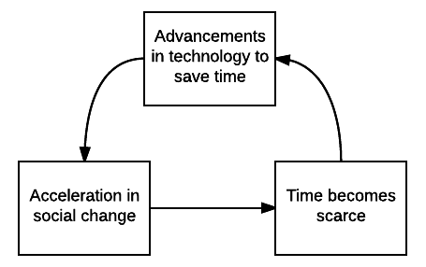

**Role of information explosion**

The more information becomes available, the more pressure there is to keep up. As of 1989, the amount of available information doubled every five years and a weekday edition of the New York times contains more information than the average person was likely to come across in a lifetime in seventeenth-century England (Wurman, 1989). Today, the amount of data in the world doubles every 18 months (The Economist, 2011). With the mounting pile of information to go through, the fear of being caught ignorant is partly what drives information anxiety – a term coined by Richard Saul Wurman (1989) to describe a state of anxiety caused by “the ever-widening gap between what we understand and the information that we think that we must understand.” The pressure to ingest an ever expanding amount of information in a given amount of time creates the feeling of time pressure.

**Role of secularization**

Due to secularization, the idea of the fulfilled life no longer supposes a “higher life” waiting for us after death, but rather consists in realizing as many options as possible from what the world has to offer. If we live twice as fast, or if we take only half the time to realize an action, goal, or experience, we can live two lives in one lifetime (Rosa, 2010).

The modern world always has more to offer than can be experienced. The gap between the two increases as more options to experience the world become available. In the words of German philosopher Hans Blumenberg (Rosa, 2010)., “time in the world and the time of an individual life dramatically diverge” The perception of experiencing an increasing smaller portion of the world further pressures us to reduce the gap between the time of the world and time of our lives (Rosa, 2010).

**Role of money**

Ever since a clock was first used to synchronize labour in the 18th century, time has been understood in relation to money (The Economist, 2014). Once hours are financially quantified, people worry more about wasting, saving or using them profitably. This is because in individualistic cultures, which emphasize achievement over affiliation, created an urgency to make every moment count (Levine R. , 2008). When people see their time in terms of money, they often sacrifice the former while trying to maximize the latter. Those who are paid by the hour volunteer less of their time and tend to feel more antsy when they are not working (DeVoe & House, 2012). when people are paid more to work, they tend to work longer hours, because working becomes a more profitable use of time. Wealthier cities like London and New York pay people more for them time. New Yorkers and Londoners are more harried than residents in cities like Nairobi and Lima (The Economist, 2014).

**The role of constraints**

Part of the reason why people feel pressed for time comes from working longer hours and not leaving enough time for leisure. In 1930, John Maynard Keynes imagined a world in which, a hundred years later, work would be to a large extent replaced by leisure. He speculated about a 3-hours shift and a 15-hour workweek by 2030 (Korunka & Hoonakker, 2014). In reality, the share of employed American men regularly working more than 48 hours per week have increased over the last 25 years (Kuhn, Lozano, & Fernando, 2005). One explanation for why productivity increases did not lead to a shorter work time include people’s need to compete against each other and seem productive and loyal in a time of high competition and low job security. The average employee takes only half of their allotted holidays, and 15% do not take any holiday at all (The Economist, 2014). The arms race between people drives up work time for everybody.

Given the natural tendency for people in individualistic societies to get into an arms race, what keeps work time from escalating are technological and legal constraints. Smartphones removed the constraints and allowed work to flow into what used to be leisure time. 60% of those who use smartphones are connected to work for 13.5 hours or more a day (The Economist, 2014). The Amish is not connected to electricity because they anticipate that easy access to electricity would make for longer work days and reduce time spent in the evening with family (Trollinger, Selling the Amish: The Tourism of Nostalgia, 2012). Europeans work less than Americans because labour-friendly governments in Europe capped working hours and mandated holidays, which are less costly when everyone is taking time off (The Economist, 2014).

Reducing the value of working more also prevent people from working more than is needed. In immediate-return hunter-gatherer societies without a means of long-term food storage, there is no value in harvesting more than can be consumed within a short period after its harvest. Since harvesting animals and plants from the wild faster than their rate of regeneration would deplete nature’s food supply, it would also be counter-productive to work more than was needed (Gray, 2009).

# Nostalgia: a vehicle for creating a home away from home

Modernization is a double edged sword that led to a level of material affluence unimaginable by people in pre-modern societies, but also an environment where people feel a lack of deep connections and feel pressed for time. What characterizes modernity – urbanization, industrialization, technological advancement, secularization, consumerism, and westernization – are in direct conflict with environments that foster intimacy and prevent acceleration in pace of life. Since these characteristics of modernity are deeply embedded in our culture and are likely to persist into the future, there will be an increasing need to help foster resilience among individuals in what Giddens (2013) calls a ‘runaway world.’

One way to introduce a sense of intimacy and reduce the feeling of time pressure in the modern context is to side step their inherent conflict – by creating a home away from home. Nostalgia is an appropriate vehicle for doing so, as it is described by psychologists as a “benign mechanism that eliminates the effects of self-threats, without countering it directly, by affirming essential positive aspects of the self” (Wildschut, Sedikides, Arndt, & Routledge, 2006).

Given the scope of of the challenge, it may seem trite to suggest that nostalgia is an appropriate response. Upon hearing the word ‘nostalgia,’ it would not be surprising for someone to conjure in their mind the imagery of a person passively reminiscing about the past, without doing anything to change the present. It can however be argued that while nostalgia can indeed be experienced as an activity of pure remembering – when a research participant is asked to write a nostalgic narrative for example, it can also be experienced as immersion in a different world -- for example, when tourists of Amish country experience “walking, browsing, and resting amidst a setting… and being invited to inhabit that story and become subjects of it.” As explained in the section, An Alternative Heuristic, since cues from the past are needed to evoke the experience of nostalgia, and that a world is a gestalt of these different cues, creating fully immersive nostalgia experiences is akin to creating a different world.

Designers are in a unique position to shape culture and individual experiences. By embedding nostalgia in the design of new experiences, we can create comforting moments of home in people’s experience of the modern world.

A caveat is needed to avoid misunderstanding of ‘designers’ as those operating in a pure commercial setting, and misunderstanding the intent of this research as to exploit the use of nostalgia to further consumption of products and services. Designer in this research is defined broadly. It **includes any individual who partakes in the activity of design – the conception or creation of change of any kind or scale that has an impact on others. This broad definition is used because this research is intended to empower any individual to think about how nostalgia may play into their everyday work. Innovator, entrepreneur, engineer, urban planner can all be considered as “designers” in this research. The word ‘experience’ is not necessarily a consumerist concept. It is, according to** Hassenzahl’s (2010) definition, “a story, emerging from the dialogue of a person with her or his world through action.” A**s mentioned in the** Social Implications **section,** nostalgic experiences have the potential to reduce consumerism, as it gratifies people’s need for belonging through experiences – that prioritize sharing and inter-reliance, for example – that embody values that are in stark contrast to the alienating values of the modern, consumerist society.

## Value for producers and consumers

For nostalgia to make widespread impact, it is important to align nostalgia with the incentives of the economic system, the most efficient and far-reaching method of distribution any social or commercial offering. It needs to be seen as valuable for all players in the economic system – including both producers and consumers.

Nostalgia does not only create emotional comfort for people, it is also a valuable asset that consumers are willing to pay an extra premium for. As shown through a series of studies (Lasaleta, Sedikides, & Vohs, 2014), by fulfilling people’s need to belong, people are more willing to pay and are less sensitive to price.

Nostalgia is also an effective tool for building loyalty. In advertising, it has been shown that “nostalgic thoughts and pleasant memories in consumers [results] in enhanced attention towards the ad, more favorable brand attitudes and purchase intentions,” with the largest effect shown for people who once had some direct exposure to the brand or product (Meuhling & Sprott, 2014).

# Heuristics for using nostalgia as an approach to experience design

Roger Martin in his seminal book The Design of Business defined innovation a process that begins with a mystery, becomes a heuristic (an aid to problem solving), and develops into an algorithm (a recipe). He called this process the “knowledge funnel.” As a mental model, heuristics are meant to bring some order to mystery, which is inherently complex. This order can take the shape of a list, a hierarchy, a process, a cycle, a relationship or set of relationships. A rule of thumb for creating heuristics is to visualize them.



Embedding nostalgia in experience design is a mystery. Existing heuristics developed by marketers and designers are drawn upon, in conjunction with literature review, to inform the creation of new heuristics that help designers use an nostalgic approach to experience design.

## Existing heuristics

There are three existing heuristics targeting designers – including marketers and innovators – to help them make sense of how nostalgia can be leveraged to bringing about new offerings. These heuristics are individually examined and new heuristics are proposed to fill in the gaps.

### Goals for nostalgia in design

(Leberecht, 2013)

Tim Leberecht, the CMO of architecture and design firm NBBJ, and the former CMO of Frog Design, wrote an article (2013) featured in Fast Company that highlighted three kinds of “retro-innovation,” a term he coined to describe “new products and services … designed to connect us with the past in ways that are both nostalgic and interactive.” The three methods included:

1. Innovations that authentically mimic a product or experience of the past to transport the user back into a gone era.
2. Innovations that use a traditional format to meet a new need.
3. Innovations that use a new format to meet an old need.

### Approaches for past experience

(Brown, 1999)

‘Retro marketing’ was first conceived as a marketing concept by Stephen Brown (2001), who coined the term ‘retro-marketing’ and describes it as "the revival or restarting of products and services which belongs to the previous historical period.” To give some outline to the amorphous concept of retro-marketing, Brown (1999) identified three key forms or manifestations of the phenomenon:

1. Retro
2. Repro
3. Repro-retro.

According to Brown (1999), Retro refers to “combining the old with the new, usually in the form of old-style styling with hi-tech technology.” In contrast, “repro pertains to reproducing the old pretty much as it was.” Lastly, repro-retro, as described by Brown (1999), “comprises revived revivals, nostalgia for nostalgia itself and state-of-the-art reproductions of past state-of-the-art reproductions of the past.” As an example, Star Wars, which parents took their kids to see out of nostalgia, was actually an attempt to recapture the experience of watching “Saturday afternoon serial of the Buck Rogers type” in the 1930’s and 50’s - alien villains, American heroes, heroines in distress, death ray or the doomsday box.

### Means of evoking a nostalgic experience

(Xue & Wooley, 2011)

While the term ‘retro’ could be interpreted in a variety of possible ways, Xue and Wooley (2013) pointed out that industrial designers generally use the word to describe “combining a heavy influence of what might be construed as old fashioned visual elements but do does not involve sufficient original and innovative design input.” Xue and Wooley clarifies their stance by writing “by making new design work look old is one way to achieve [nostalgia], but it is neither the only approach nor necessarily a good one.” As Xue and Wooley (Nostalgia and Its Value to Design Strategy, 2011) observed that “it is not wise to keep producing things just look old, because the market is already full of this kind of products.” They proposed (The Charm of Memory: examining nostalgic experience from a design perspective, 2011) an alternative, in which “social interactions or other interactions can be designed aiming at evoking nostalgic experience.” The different ways of invoking nostalgia are visualized in this heuristic:

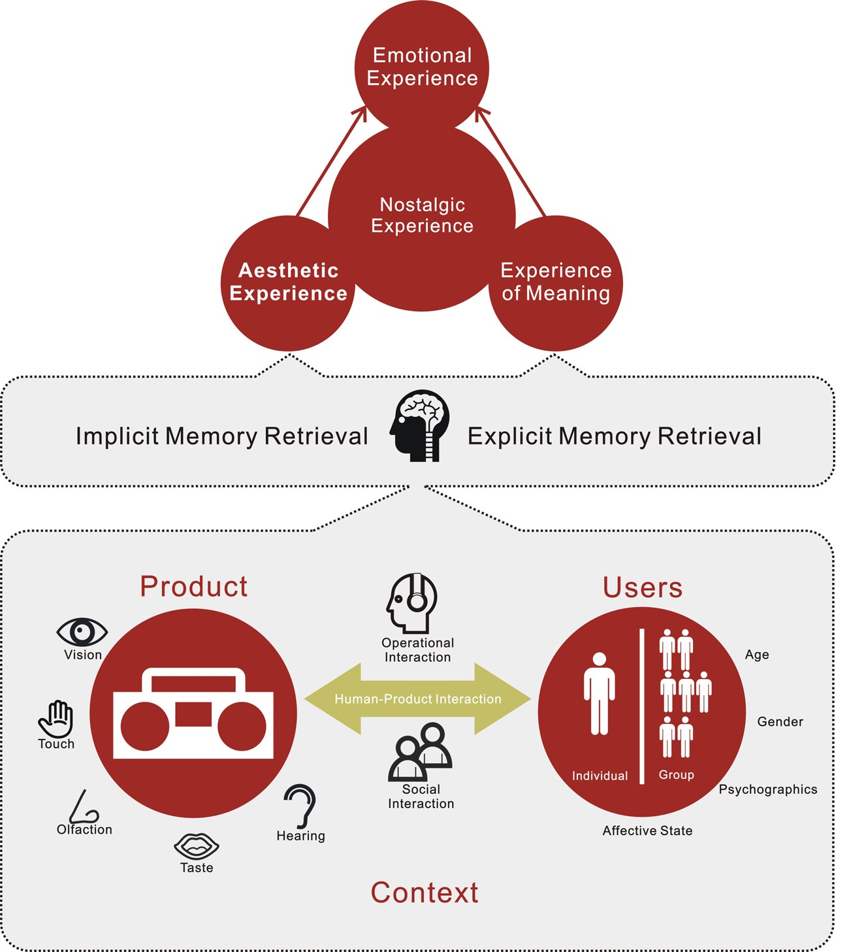

## Proposed Metaheuristic

A metaheuristic – to borrowing the definition from computer science -- is a higher-level heuristic designed to find, generate, or select a heuristic (Bianchi, Dorigo, Gambardella, & Gutjahr, 2009).

To better make sense of how different heuristics for leveraging nostalgia in design, a metaheuristic is proposed:

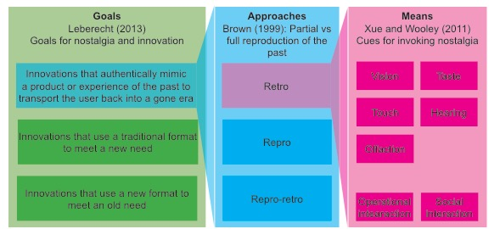

Leberecht’s (2013) heuristic concerns the different goals of using nostalgia in design.

Brown’s (1999) heuristic assumes the goal of transporting the user back into the past and concerns whether the past is reproduced into the present in full (repro) or in part (retro).

Xue & Wooley’s (2011) typology of cues makes explicit the different dimensions of the past experience that can be mixed into the present experience as cues to evoke nostalgia.

As a scaffolding tool for different nostalgia heuristics, designers can better understand the unique perspective that each heuristic offers in relation to design. This allows designers to be more intentional with the kind of heuristics they use, and establish a common language for designers trying to engage with nostalgia. The metaheuristic provides a higher level scaffolding for existing heuristics, but does not question the strengths of the heuristics that it contains. A deeper analysis is needed.

## Critique of Existing Heuristics

While Leberecht’s (2013) heuristic is useful as a starting point to categorize different ways that nostalgia intersects with design and innovation, there is not sufficient clarity around the definition of the terms new needs, old needs, and new format, and old format. One of the examples that Leberecht used as a traditional format addressing a new need is the artist who released an album as sheets of music for his fans to compose together via the internet (Leberecht, 2013). While co-creation is labeled as the new need, it can also be framed as a new format, which meets an old need of cooperation. While music sheets are considered as old format, it can also be considered as bringing people back into a gone era, or as meeting a need as paper allows for deeper reading comprehension (Mangen, Walgermo, & Brønnick, 2013).

Brown’s (1999) heuristic makes a useful distinction between reproducing the exact same experience from the past (repro) in the present or mixing elements from the past experience with the present experience (retro). While these definitions work well for the product context -- as a product has clear, physical boundaries – when considering someone’s experience, the contexts to be taken into account as well. Since time period is part of the context, then context is always changing. So theoretically reproducing a tangible artifact is possible, but reproducing an experience is impossible. Compared to retro and repro, retro-repro introduces an additional dimension of recursion, which raises the question of whether retro-repro should be categorized alongside retro and repro.

Xue and Wooley’s (2011) heuristic makes a contribution to the understanding of leveraging nostalgia for design by mapping the relationship between cues, product, interaction, and the user. The heuristic is intended for designing physical products, hence it makes sense for cues -- sensory, operational, and social interaction – to surround the product. In the field of experience design, and in prior analysis of the nostalgic experience, the ultimate goal of design is not to build a better product – although a better product is often the outcome of successful design – but to influence user’s feelings. The placement of “affective state of the user,” in Xue and Wooley’s heuristic does not convey feelings as the most important element of design. In this heuristic, age, gender, psychographics, and the affective state of the user, and whether the user is by herself or among a group influences the likelihood, enjoyment, and interpretation of the nostalgic experience. These characteristics can also be seen as cues that inform the content of the nostalgic experience.

## An Alternative Heuristic

Integrating ideas from existing heuristics and concepts derived from literature review, the proposed heuristic provides an alternate perspective for understanding nostalgia, in order for it to be more strategically embedded in experience design.

The proposed heuristic adds a different perspective of understanding nostalgia than existing heuristics for the purposes of embedding it in experience design. It differentiates from existing heuristics by organizing the nostalgic experience into layers, with ‘feelings’ – a mood, a spirit, thoughts, or emotions of a previous time – at the center and the ‘world’ on the outside; and conveying different effects that cues at different layers can play in evoking nostalgia. The different elements in this heuristic are further explained below, through examples from a hunter-gatherer experience scenario.



**Cues**

“Courage”, ”hunting”, and ”hunter-gatherers” describe – respectively – a feeling, an activity, and a world. These things have one thing in common – they are all ideas. We recognize something as “hunting” when elements that make up the idea of hunting are perceived as a gestalt. They are called cues because they ‘cue’ the idea of hunting in our minds.

Cues can be something you hear, something you touch smell, an object, or a person**.** They can be delineated in an indefinite number of ways. Xue and Wooley’s (2011) heuristic delineated them by type of sensory input – sight, hearing, touch, smell, taste. They can also be delineated using a common ethnographic framework such as AEIOU (activities, environment, interactions, objects, users).

These cues – if assembled the same way as they did in the past, can replicate the exact same experience. This is behind the concept of Repro (Brown, 1999). If some elements of the past experience are mixed with elements from today’s experience, then it becomes retro (Brown, 1999). This proposed heuristic does not explicitly distinguish between repro and retro because they are different points that belong on the same spectrum.

**Layers**

The nostalgic experience is organized as four layers: feeling, activity, essence, and world.

**Feeling**

At the center of the nostalgic experience are the target feelings that aims to be brought into the present. An example is a sense of cooperation.

**Activity**

Feelings are born out of interaction with the world and people within it. These interactions, taken as a whole, are grouped under the label activities. An example of an activity is hunting. Examples of cues for hunting may be an arrow, a prey, the natural setting, and tall grass for camouflage.

**Essence**

Within an activity – hunting a deer for example – some cues are more important than others in giving rise to certain feelings. These cues – taken together – form the essence of the activity relative to the desired feelings. For example, a sense of cooperation has little to do with the type of prey, the location of the hunt, or even the act of hunting itself; what gives rise to the feeling in the activity of hunting is a reliance on each other’s unique strengths to achieve a shared goal. In other words, the essence is the answer to “what *about* the activity that gives rise to a feeling?” Since these cues likely involve operational and social interaction, they might not be as immediately recognizable as the cues that are part of the activity.

**World**

The “world” is the broader context – a general time and/or place – that activities and feelings are situated in. Cues that make up the world layer may not be a part of activities that give rise to the target feelings. But reminding individuals about the world may trigger associations in memory to the target activities and feelings. For example, while Converse shoes might have had nothing to do with watching the moon landing with family and the patriotism that was felt, seeing it may evoke memories of that world and subsequently those feelings.

**Different layers of cues and their effects**

Cues at different layers of the experience have different effects when it comes to evoking nostalgia. The closer to the center a set of cues are used to evoke nostalgia, the greater the chances of success are of being able to activate the targeted feelings.

**Embedding this heuristic in a workshop**

One way to determine the viability of this heuristic is to prototype it in a controlled setting. This was done by creating a workshop guide based on the heuristic, which was prototyped with six designers. By embedding the heuristic in a step-by-step process that can be carried out through a workshop format, it can be more readily applicable in a real-world setting.

# Workshop for embedding nostalgia in experience design

A workshop guide was developed based to turn findings emerged from this research into an actionable series of steps that can be easily practiced. This workshop guides designers through a process that involves identifying positive elements from the past that are missing from our experiences today in a particular context, and generating ideas to bring them into the present through creation of new experiences. The primary goal is to facilitate the creation of new experiences that bear more resemblance to home. The secondary goal is to create unique experiences that can compete in today’s experience economy. The meta-goal is to educate participants through first-hand experience on how nostalgia can be used as an approach to create new experiences.

This workshop guide was piloted with six designers, with the aim of measuring how close the workshop guide achieves its intended goal, and getting feedback on how it can be refined for future iterations.

## Workshop activities

The workshop was broadly comprised of four activities: goal setting, anchoring in context, immersion, and ideation. They are intended to be carried out in sequence.

**Step 1: Emotional goal setting**

When participants entered the room, they are given a sheet that contains a set of 60 emotions. Participants are asked to circle three to five that they would like to experience more of. They would be asked in step three of the workshop to identify cues that trigger these feelings.

**Step 2: Anchoring in context**

Following this, participants are asked to read an essay provided by the facilitator that summarizes the hunter-gatherers’ way of life. The goal of the essay is two-fold. One, it anchors participants around some base knowledge on the hunter-gatherers’ way of life to prepare them for the immersion phase. Two, it was intended to induce nostalgia among participants for positive aspects of the hunter-gatherers’ way of life. There are three reasons why hunter-gatherers were chosen as the context for this exercise.

1. Since participants come from different cultures, hunter-gatherers is a context that everyone can relate to and contribute to a conversation at an equal capacity.
2. There are inspirations we can take from the way of life of immediate-return hunter-gatherer societies, such as fierce egalitarianism, which ceased to exist when most of humanity began to “plan ahead” in order to survive, beginning with agriculture.
3. The greater contrast between the present-day and hunter-gatherers, than between present-day and a more recent context, would help participants think outside the box and generate more creative ideas.

**Step 3: Immersion in the past**

Third, participants are asked to separate themselves into pairs and go to one of the stations around the room, which was set up in advance with a 48”x72” service ecology map adapted for this exercise. (see diagram below) They are asked to step into the shoes of the hunter-gatherers and unpack their experience of eating. The service ecology map serves as scaffolding for participants to think holistically about the experience and visualize their findings.

The map contains three concentric circles - each representing a step in the experience of eating (e.g. hunting, preparing, eating). The ‘slices’ of the map represent different dimensions of the experience:

**Constraints** what are the natural, social, and economic constraint that caused hunter-gatherers to behave in a different way than people today?

**Activities** what are the different stages of the eating experience? What were people doing?

**Emotions** how did people feel as a result of engaging in those activities?

**Environment** what surroundings did people find themselves in? What did they hear, see, feel?

**Objects** what were the tools and objects that people interacted with? (e.g. bow and arrow)

**People** how many people were present? who were in the experience? What roles did they play? What is the relationship between different people?

**Interactions** how did the environments, objects, people interact with each other? (e.g. motions that people had, objects that responded to the environment)

**Time** what times of the day did the activity take place? What was the duration and frequency?

Anchored in basic knowledge about hunter-gatherers, participants are encouraged to imagine the rest. This is because nostalgia not selection and ordering of facts, but a “a sanitized impression of the past (Hirsch, 1992)” and “active myth-making (Chilton, 2002).” By giving participants freedom to imagine, it might reveal themes that are unanticipated, as Wilson (2005) wrote, “perhaps we nostalgize for those things which symbolize what we wish for.”

In completing the map, participants were encouraged to emphasize those activities with the biggest impact on those feelings they circled in Step 1. To help participants empathize with hunter-gathers, participants were provided a sheet containing a list of senses (i.e. touch, taste, sight, hearing, and smell) that they could use to imagine different dimensions of the experience.



**Step 4: Ideate for the present**

The final stage involved asking participants to generate ideas to enhance or transform the modern eating experience by using what they put down on the maps as inspiration. Participants were provided creative prompts to support divergent thinking. As an example, what mediums (e.g. object, an experience, ritual, etc.) can you create an experience for? Can you create an educational or escapist experience? Can you create an artificial constraints using modern tools? To communicate the ideas, participants were given templates that asked for a title, a sketch, and a description.

**Step 5: Discussion and feedback**

Participants were given the opportunity to have a free-form discussion with the group at every step along the way. Time was allotted at the end to share their ideas with the group and reflect on the overall experience.

**Workshop photos**

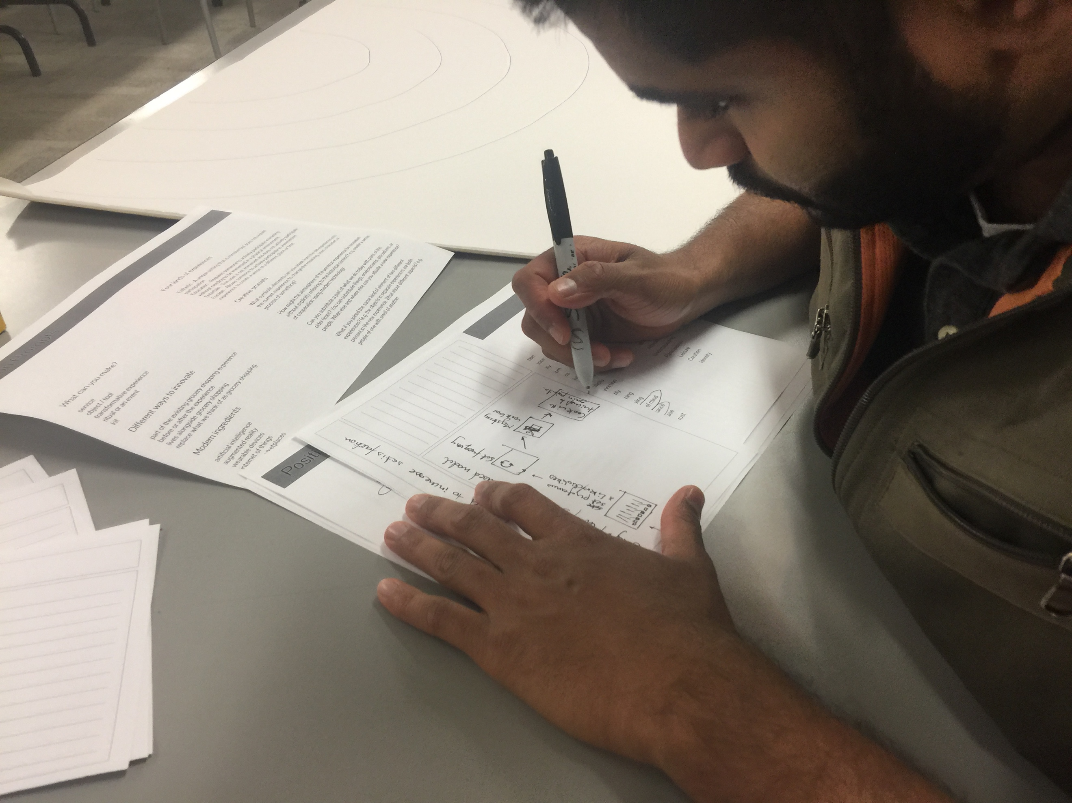 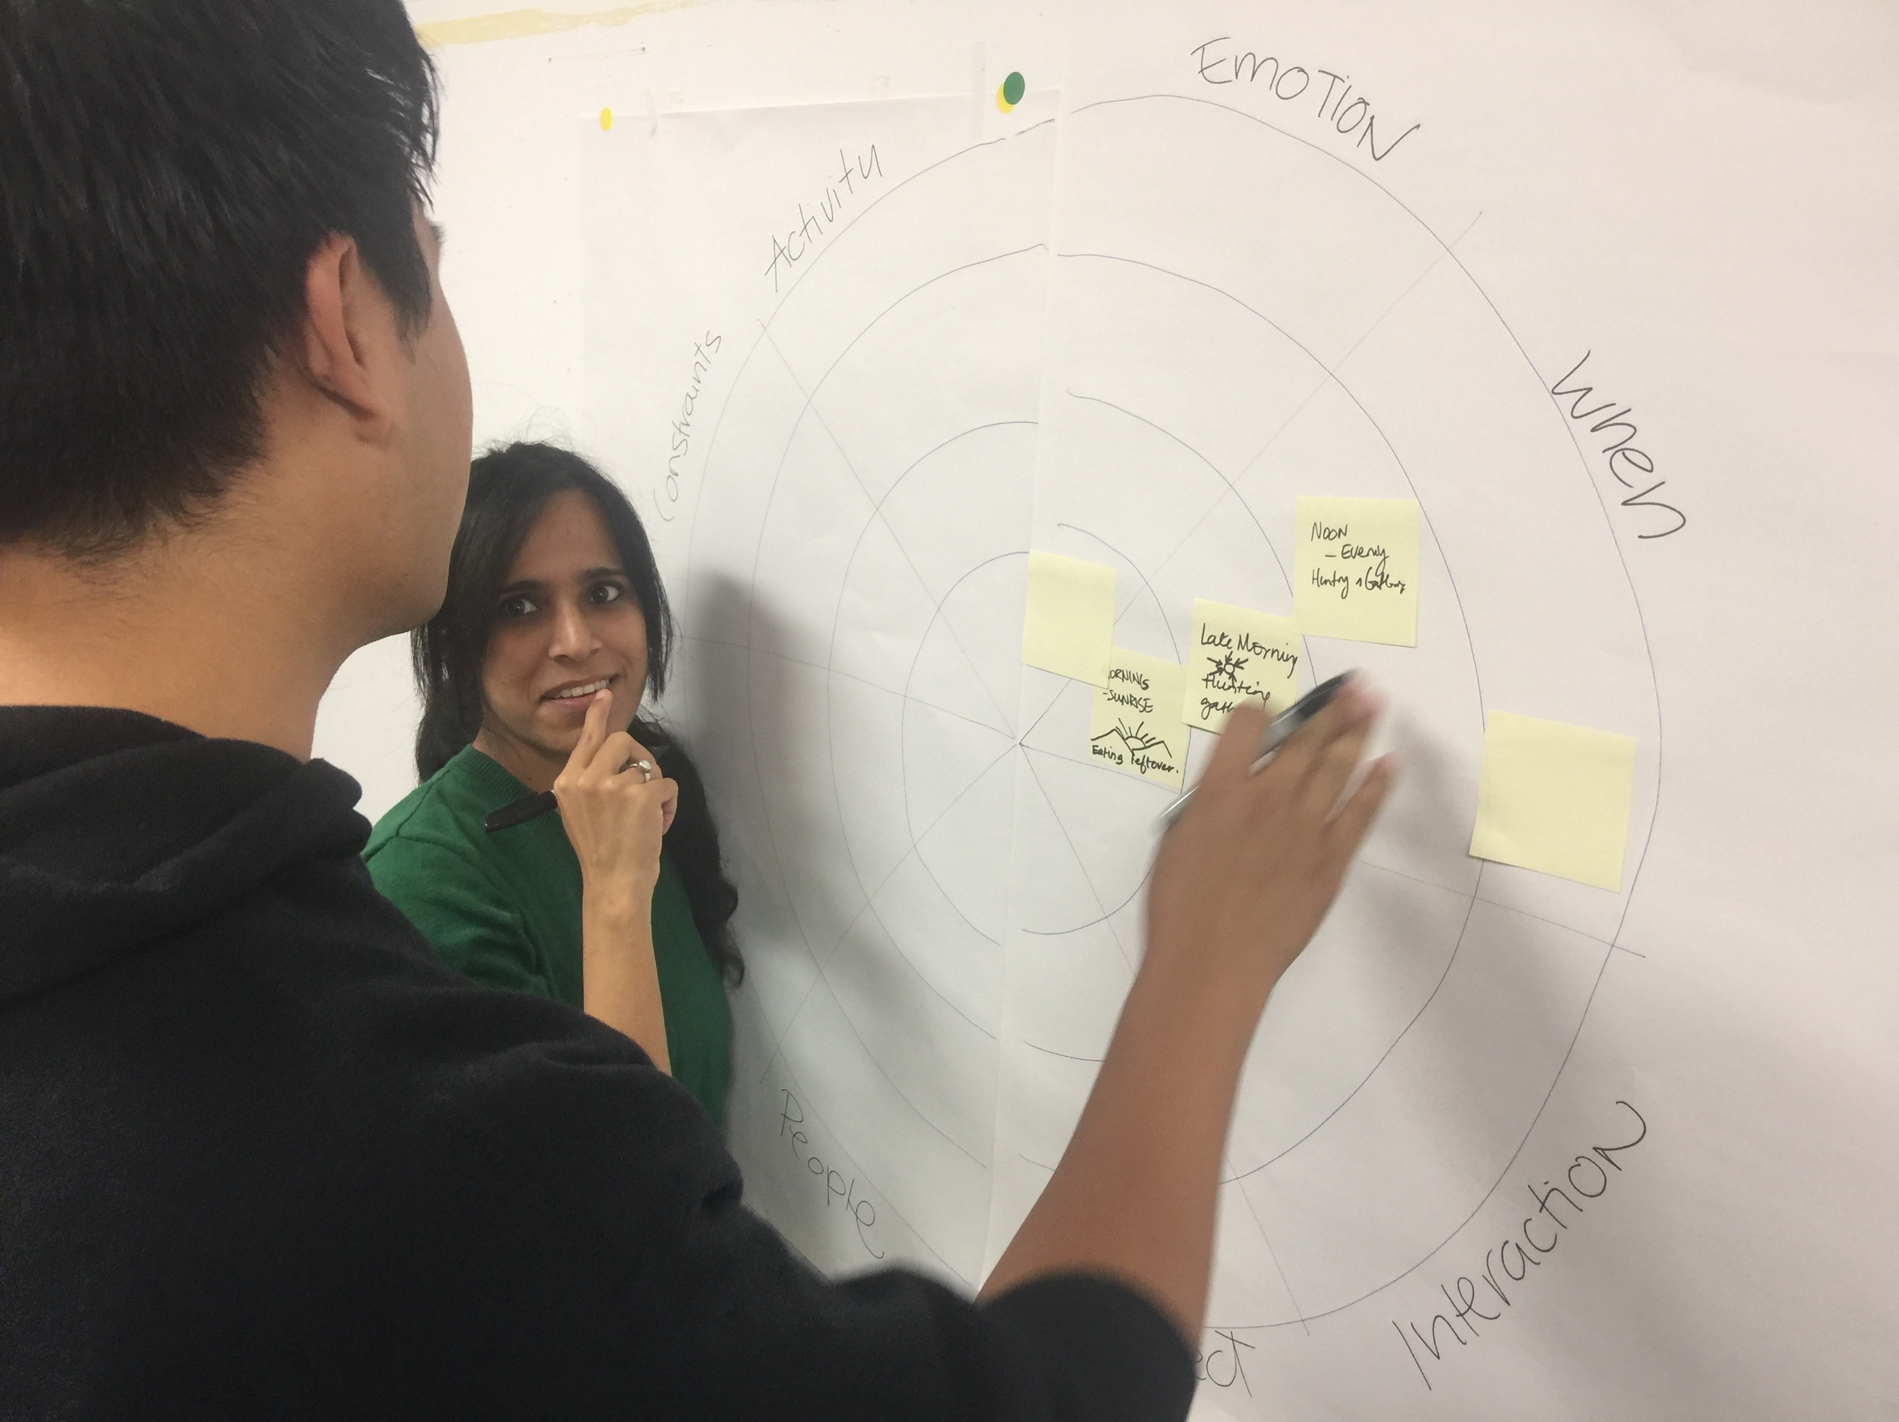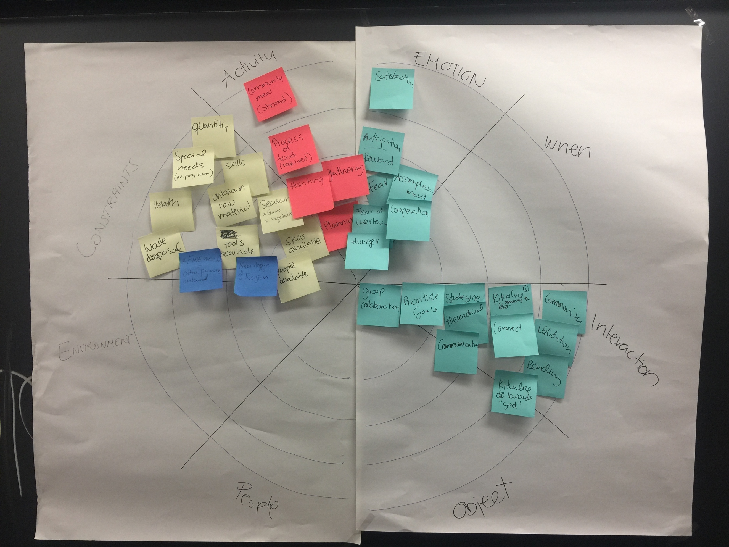 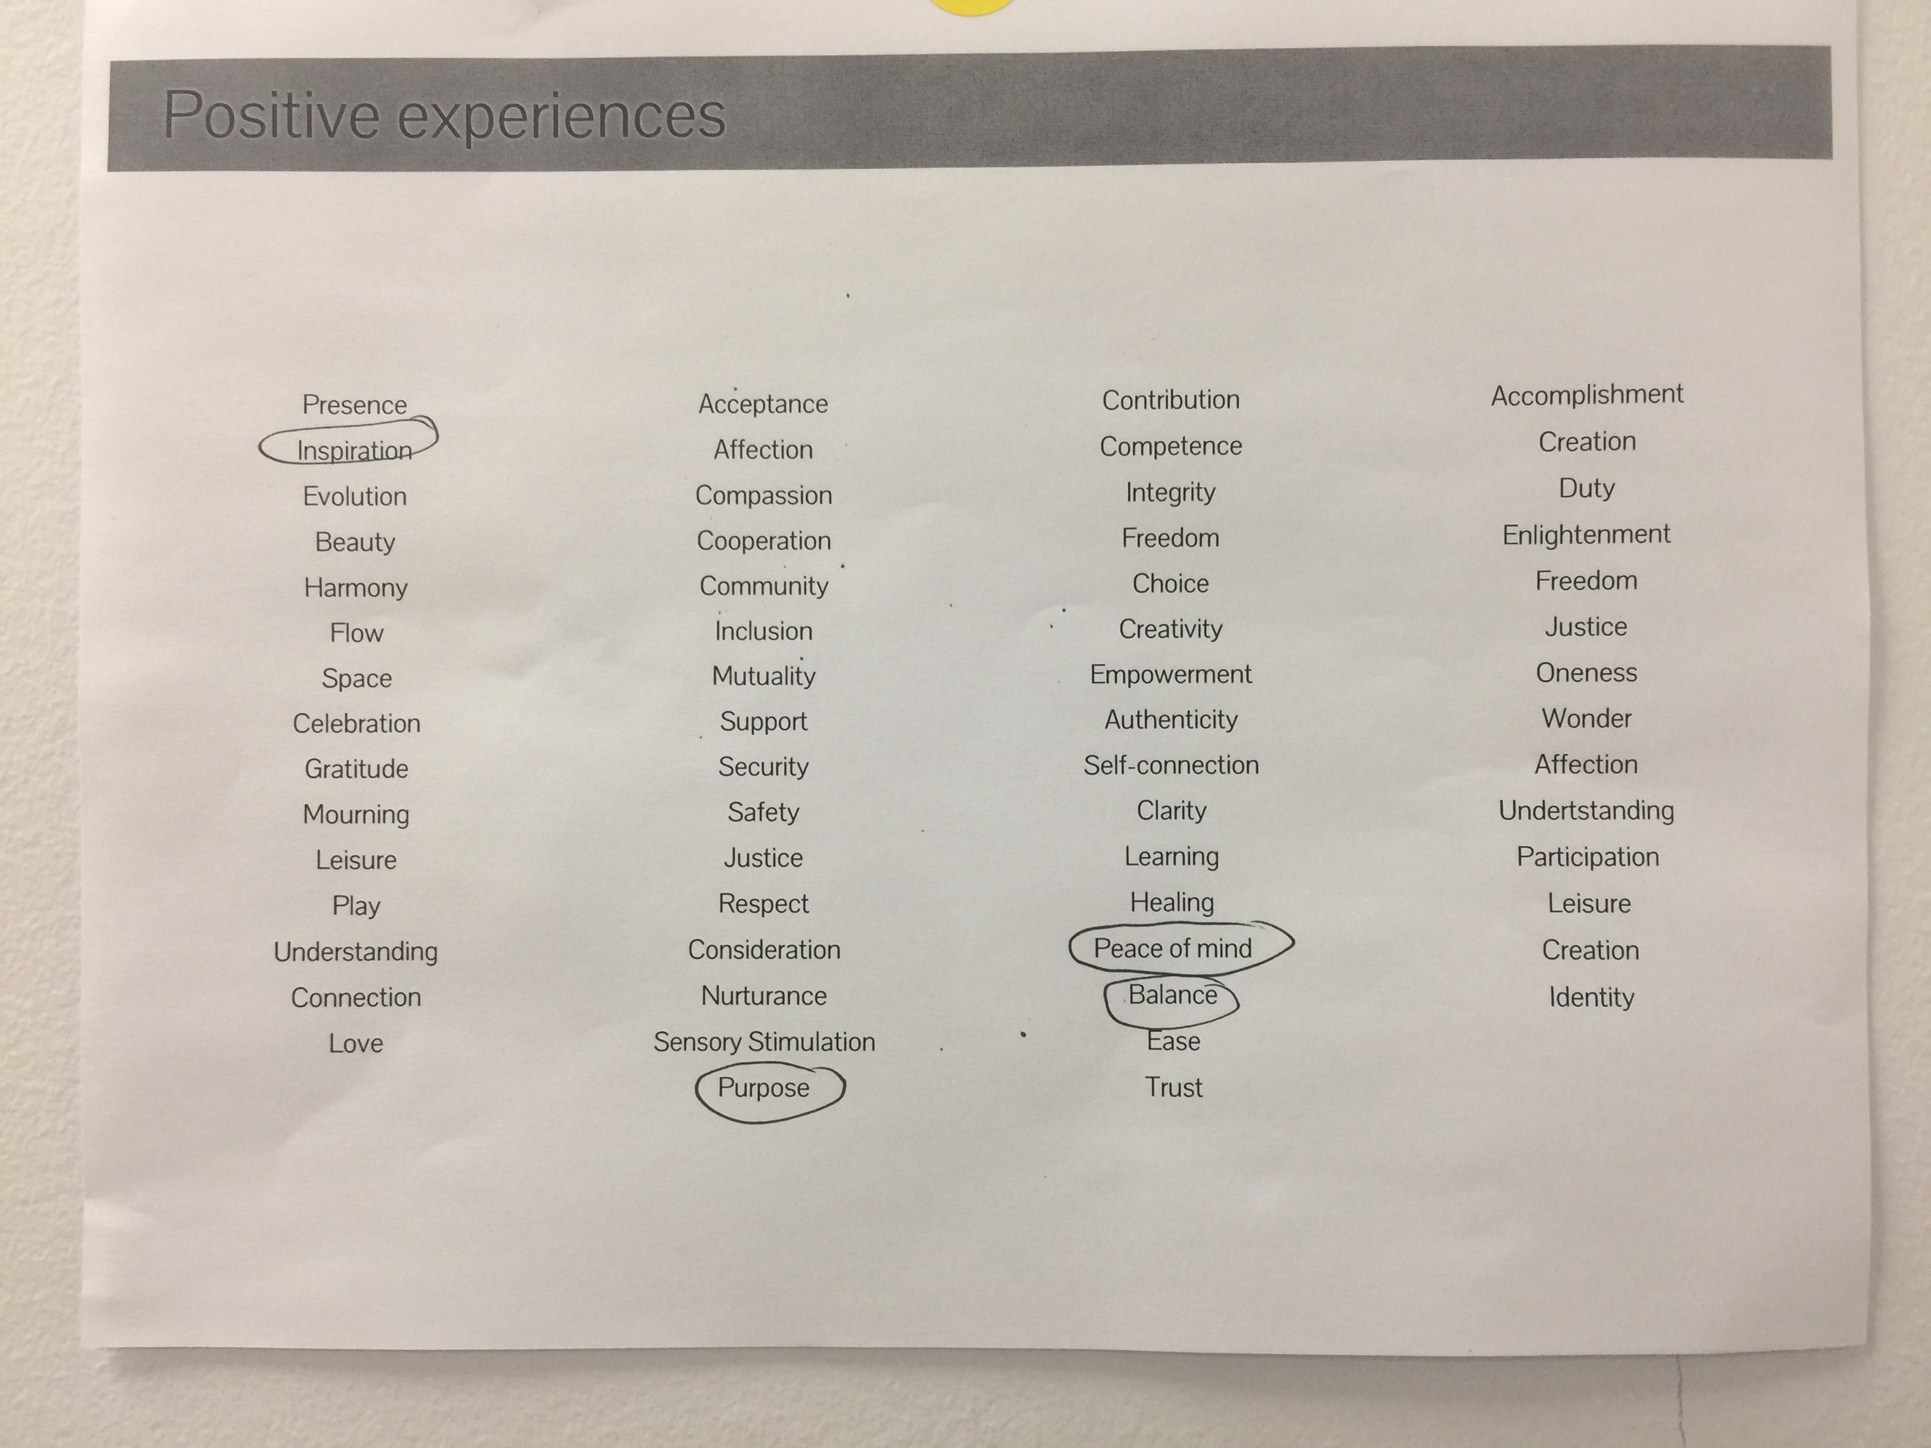

## Themes generated through conversation

By giving room for people to imagine the past, participants identified many aspects of the past experience of eating surpasses its present counterpart. These themes are diverse and went beyond intimacy and slowing down time. They are decontextualized from the eating experience, and are framed below as design principles for embedding nostalgia into experience design in general.

**How might we build in challenge and anticipation?**

The emotional response to an experience is much higher if there is anticipation of the reward built into it.

“Today when you are hungry, you go around the corner or use Uber eats to drop it off. The effort is uniform. When you actively had to engage in the activity of acquiring the food, both the effort and reward were variable (the amount and kind of food). So at the end of the day the emotional value of food was always high. Success had much greater value than it does today, because of the challenge you associate with the experience.”

**How might we create a group ritual?**

People’s lives are influenced by so many external factors today that having a consistent ritual that they can regularly retreat to gives people a sense of continuity in their lives.

“Today we often eat alone, whereas back then people always together with their community. I want to be able to cook and eat with other people on a regular basis. The key is consistency.”

**How might we help people stay in the present?**

We experience a lot of chronic anxiety today from worrying about the future. The further we try to plan, the more our current actions seem to matter. We are quickly overwhelmed when every small decision seems like a fork in the road to alternative futures. Nudge people to focus their attention on their immediate surroundings to free them from worry.

“Since they probably did not keep track of years, their lives followed a daily cycle that remains the same from day to day.”

**How might we give people a regular sense of accomplishment?**

We set so many goals for ourselves nowadays that meeting the most basic needs – having food to eat, having a comfortable shelter to retreat to – just do not feel like accomplishments. Even the sense of accomplishment that comes with sizable achievements is quickly dwarfed by everything else waiting to be done. In the old days, everyday we feel a sense of accomplishment from meeting our most basic needs. Nowadays when that feeling comes rarely, celebrating the little steps becomes extra worthwhile.

“You have so many things to accomplish now that maybe you don’t appreciate anything that much. Back then, getting food was the only goal you had that your satisfaction was greater when you accomplish that.”

**How might we chunk the experience?**

It is hard to notice how much we have when we get used to the little pockets of pleasure of daily life. Regulating the speed at which positive experiences are ‘consumed’ allows people to appreciate the experience to its full extent.

“We were thinking in cultures where there isn’t a lot of food if you divide the food in smaller chunks and use smaller utensils, it creates the impression you’re eating more.”

**How might we create opportunities to share a prized resource?**

Sharing something that is prized builds a kind of trust that is normally reserved for close friends and familial kins. The things that we prize the most are often not high in monetary value but high in emotional value. Getting people to embed emotional value into something and sharing it with others is a way to build trust.

“Food was prized because it was scarce. Eating with someone is a vulnerability activity and it says ‘I trust you enough to share with you a limited resource that is not everywhere.’ if I have little and I share with you, it creates shared interest.”

**How might we impose constraints to spark creativity?**

People are naturally creative. And creating makes life feel meaningful. But given the routinized environment that we normally find ourselves in, there is little need to be creative. Designing situations where people are challenged to be creative renews their sense of creativity.

“When people hunt and gather without knowing the area well, the constraint was unknown raw materials. You made the most with what you’re given.”

**How might we give each person a role to play?**

People feel most meaningful when they have something unique that they can contribute to the collective good. In our society today, it is easy to feel redundant as there is always someone better than you at something. When a person is given the opportunity to be the best at something in a given setting, it gives them a sense of being valued.

“Everyone had unique skills and they had work together to successfully hunt and process food.”

**How might we induce a state of focus?**

We are, in general, losing our ability to remain focused due to two changes in our lives: the amount of information we have to process, and the plethora of technologies we use to process that information, which are designed to get our attention and keep us clicking. We long for a state of mind where we are not tempted by distraction but rather focused on the task at hand.

“Because hunter-gatherers had only one task, all their attention was to accomplish that task. But today our attention is so diverted because there are so many tasks to do.”

**How might we inspire a sense of wonder?**

We get a sense of wonder when we are face to face with something that is beyond our understanding, especially as part of a group. Looking into a fire, listening to a story about a mythical past, and conversing with the gods are all things that gave us this sense of wonder.

“When people gather by the fire after they eat, they tell stories about the gods. It gave them a sense of wonder about their place in the universe.”

## Ideas for experiencing food differently

Inspired by discrepancies between the experience of eating in the past vs in the present, the ideas generated were diverse and innovative. Nearly all of the ideas generated through the workshop involve a community aspect. This aligns with the previous findings that intimacy is desired.

**“Supper Bowl News”**

A bowl whose surface is able to display information about the food as you eat. This newfound sensibility about what you are eating and where it comes from helps you appreciate food.

**Online communities for ritualized food prep**

Online community that makes arrangements for people to take part in the communal activity of preparing and eating food on a consistent basis. As a ritual, it gives people a sense of participation and ownership.

**“The Gathering”**

A new dining experience situated near an athletic facility in which diners “put in the work” before eating. The design of the space is nostalgic of gathering in a circle and eating around a campfire.

**“Commune”**

An app that livestreams a group of friends, allows them to simulate the experience of eating together without being physically co-located in one place.

**Collaborative cooking**

An event management service that brings people together with different resources. One can offer food, somebody can offer space, someone can offer a recipe. someone can cook, and someone can offer an ingredient. Only when individuals come together will the group know what they are going to eat. This shared experience creates the feeling of connection and discovery.

**Food adventure**

An immersive experience that takes participants through a scenario set in another time and place by getting them to complete tasks and solve puzzles and get rewarded with food in return. For example, the pig-shaped prop has meatballs that you can unlock by shooting the arrow onto the target

**Mystery meal delivery**

Meal delivery service that – after you set your food preferences – sends you a mystery box containing familiar and unfamiliar ingredients that are in season.  Bonus points if you pair up with someone else’s mystery box and experience cooking and dining together.

## **Feedback and Reflection**

A survey was sent to participants after the workshop to collect their feedback on four areas:

* + Validity of nostalgia as an approach to design
  + Using hunter-gatherers as a way to frame the workshop
  + Design of workshop activities and sequencing
  + Impact on participants as problem-solvers, innovators, and designers

The feedback was positive overall,

### Nostalgia as a design approach

The feedback demonstrated that the workshop was successful in education participants about the value of using nostalgia as an approach to design. Some feedback suggests this workshop served as “an entry point to the challenge of designing with nostalgic elements.”

One participant commented on usefulness of “thinking about an imagined setting and describing it in detail.” Another reflected that “we all can see things we never thought were there if we are prompted in the right context and guided through the process.”

The workshop also allowed participants to appreciate the positive qualities of life in the past and made them realize “how nostalgic I feel about the old times when things were simpler.” They could see “why a particular activity is satisfying [to] our early ancestors” and could imagine how these insights can be applied other contexts other than eating to make the experience more satisfying.

In relation to design, the common theme from participants’ feedback was that nostalgia can be applied to “the design of experiences and services.” It can be seen as “useful design constraint… to make something foreign seem comforting.” It can be used to “create objects that have more sentimental value.” And “contribute to the creation of more satisfying experiences that can cross generational boundaries.”

### Framing of workshop

One of the dilemmas going into this workshop was whether to use the hunter-gatherer context or a context that is situated in more recent history. Being a time that is far removed from a person’s everyday experience, the hunter-gatherer context was anticipated to less likely in evoking nostalgia. Ultimately, the hunter-gatherer context was chosen because it was felt that for a group of diverse individuals, it would serve as a common platform for sharing ideas, and prescribing a certain culture would not be appropriate.

The reflections affirmed the rationale for choosing the hunter-gatherer context – to establish a common platform for conversation, - as “a topic we all relate to whatever our background.” One participant framed the hunter-gatherer context as an enhancement to creativity, “The wildly different settings and circumstances and setting lets us stretch our imagination and empathy into a strange setting.”

While the rationale for choosing the hunter-gatherer context was affirmed through participant feedback, when asked directly about whether participants felt nostalgic during the exercise, three out of six participants indicated that they felt nostalgic, while the other half indicated that they did not. One participant reflected that “nostalgia was not really a central component in this exercise.” Since nostalgia is the centerpiece of the heuristic and the workshop, it can be concluded that hunter-gatherers was not an effective context to evoke nostalgia. While the emotions experienced through nostalgia – intimacy, absence of time pressure – are near-universal, the specific events that rejuvenate those feelings for each person can vary from person to person. Therefore, it is recommended that the next iteration of the workshop prompts participants to think about different contexts, without prescribing exactly which ones to use for the activity.

### Workshop activities and process

**Immersion**

Participants expressed that the service ecology framework was easy to understand and helpful for scaffolding of ideas. The fact that it was large and posted on a wall encouraged people to build on each other’s ideas through conversation and dialog.

However, the scaffolding was too extensive and made the task of unpacking the experience of hunter-gatherers overly analytical, which took up too much time and resulted and an unnecessary level of granularity. The numerous sections signaled to participants that they had to go into a lot of detail, when the intent was to have participants bring to mind the most salient things that they would like to bring to the present.

**Timing**

The feedback indicated that less time could be spent in the discovery phase – reading about hunter-gatherers and mapping their eating experience—and more time be allocated for “assimilation and reflection.”

“I felt that we thought about the hunter gatherer problem for a long time but didn't have enough time to think about how to apply the findings to create products and services for today.”

### Overall impact

All six participants saw the uniqueness of this approach and the potential that it might have for design: “I think now that the world is focusing on hi-tech future oriented design, utilizing nostalgia as an approach to design has a lot of potential.” Out of the six participants, four indicated that it impacted them as designers, while one expressed ambivalence towards how the workshop is designed and executed, and one indicating that it did not fundamentally change their viewpoint on design.

# Ethics of nostalgia

Nostalgia is a phenomenon that is too important to ignore as a driving force for culture and as a powerful motivator for certain types of human behavior. While understanding this phenomenon can inform the design of experiences that are comforting to people, it raises some questions about how it should be used responsibly to achieve ends that serve people rather than harm them.

Nostalgia is a deeply personal experience. People’s identities and beliefs are revealed by what they are nostalgic about. As no two people have the exact same beliefs, everyone is nostalgic for different things. Sometimes the difference results in a clash of values. For example, in America different racial groups might be nostalgic for time periods in the nation’s turbulent history. Many whites remember the 1950s as the glory days of history. “Post World War II, white families were reproducing. America was nation that saves the world,” observed rhetoric theorist Susan Trollinger (2012). What one group thinks of as “the glory days” of America might very well be nightmares for another group. Trollinger continues, “You’d be hard pressed to find an African American anywhere with fond memories of the 1950s. They are more likely to be nostalgic for the 1960s when finally, people broke through racial segregation.” While African Americans remember the period as a time of liberation, “White people remember it as a time of riots. People were burning down businesses; black people with guns on the streets.”

There are opportunities for each of us to acknowledge nostalgia through a critical eye, to confront our own biases. and to heal the divisions that historically kept people part. Meanwhile, there is the danger of nostalgia being used as a tool to affirm people’s own biased views of the past and drive further division between groups. Donald Trump is a real world instance of nostalgia being used as a political platform to prey on people’s fears and propel someone to power. His campaign slogan Make America Great Again “is almost a cultural nostalgia, for when white male culture [was] most dominant,” said the Democratic pollster and Harvard Institute of Politics fellow Cornell Belcher (Brownstein, 2016). He reminds white Evangelicals, who think American life and culture “has mostly changed for the worse” since the 1950s (Jones, Cox, Cooper, & Lienesch, 2016), of the comforting time before their self-identities were under threat by the growing wave of secularization: “If I’m elected … we’re all going to be saying ‘Merry Christmas’ again” (Brownstein, 2016). When Trump casts America as a country that’s in decline due to an powerful enemy, he is creating an environment where his supporters can come together and experience a sense of solidarity that is sorely missed in modern society.

Nostalgia can be countered with nostalgia. In particular, nostalgia about a different time when attitudes and values were different. In this past election cycle for example, the Democratic National Convention mobilized nostalgia for the founding principles – the idea of America as a nation that welcomes the poor and oppressed (Trollinger, Interview, 2016).

In a way, nostalgia can be understood as a kind of psychological painkiller. It induces a positive feeling that temporarily counteracts the pain of losing a cherished feeling. Like any painkiller, it can be abused. Someone who can consistently activate nostalgia in people can use it to manipulate them. Nostalgia is a very powerful behavior incentive that should be used with care.

# Conclusion

Nostalgia is a powerful force that can be used to retrieve the positive feelings from the past. The faster the world changes, the more important nostalgia is to both consumers and producers. This research attempted to give shape to a phenomenon that is present in all facets of society, and developed tangible outputs that can empower individuals to shape the future of society – one experience at a time – to bear closer resemblance to the one that humans have adapted to over hundreds of thousands of years.

Through prototyping one of the outputs of this research – the workshop guide that help designers envision nostalgic experiences in the future – important lessons were learned on how the output can be further iterated:

* + **Simplify the scaffolding**

Rather than providing an extensive service ecology map with as many as 24 cells to fill out, simplify the scaffolding and make the question more direct (i.e. ask participants to write down what they are nostalgic about). This will drastically speed up the immersion step, which took the most amount of time in the pilot session. It will also make the exercise easier to comprehend, and thus prevent confusion among participants.

* + **Allow participants to choose context**

The rationale behind prescribing the hunter-gatherer context was to create a common platform for discussion. This limited the number of people who felt nostalgic during the workshop. To raise the number of participants who are able to tap into their nostalgia during the workshop, allow participants to draw inspiration from the past across different time periods and cultures. The simplicity will leave more time for discussion. The likely increase in diversity of ideas will cross pollinate and energize the discussion to. They could also enhance the discussion by being more emotionally charged due to nostalgia.

# Social Implications

This research laid the groundwork for using nostalgia as an approach to designing experiences. The implications of this work can create social impact in many areas

**Mental health**

Nostalgia has been found in psychology studies to improves resilience. As competition continues to increase and disruption becomes the norm, this research will help designers create more nostalgic experiences that help people be more resilient in a psychologically hostile environment.

**Sustainability**

Designing nostalgic experiences can contribute to sustainability. It can also make sustainable practices more appealing. For example, intimacy is fostered through inter-reliance. For example, framing the sustainable practice of sharing as a way to meet people’s aspirational goals of attaining a deeper connectedness with other might motivate more people to practice sharing.

**Urban planning**

Urban planners have the important role of creating habitats in which people can thrive. This research can potentially help urban planners understand what a sense of home means to people and how to draw upon nostalgia to create a sense of home.

# Next steps

The goal of this research is to spark a broader conversation about the role of nostalgia in design. The next step of the project is to involve a broader range of stakeholders in this conversation. Involving stakeholders from allows for feedback and co-creation to happen. It also opens up channels for this new way of thinking to be disseminated.

As a start, initial stakeholders to reach out to include

* Private: Design consultancies and agencies interested in adopting new design methods and tools
* Public: Social workers and government institutions accountable for the psychological well-being of the general population
* Academia: Researchers and experts in psychology, anthropology, design, and mental health

These stakeholders can be found through Google search, social media, and word of mouth. This work will be presented at conferences like the Service Design Conference, meetups and community groups like OpenIDEO, talks and professional networking sessions sponsored by various organizations.

The conversation to be had involvement of new stakeholders in on iterating the deliverables of this research, including the heuristics and the workshop.

The major foreseeable barrier is the negative connotations that the word ‘nostalgia’ has to people in our culture. Extra care must be taken to make sure that this tool is not portrayed as being against progress, but easing the pain that progress inflicts on members of society. It should also be made sure that it is not portrayed as a tool for manipulation, but a tool for helping people become more resilient to change. There are two streams of work that need to be done to take this project further. One, the workshop will continue to evolve through iterative prototyping and evaluation. To disseminate the principles of nostalgic design, a game is to be developed for designers to practice applying the nostalgic design principles derived from workshops to a broader set of contexts.

## Game: “Thing from the past”

To build on the output from the workshops, and to disseminate the approach of embedding nostalgia in experience design to a broader audience, a game is being prototyped around the design principles generated through the workshop. The game – being inherently playful – allows individuals to practice applying these design principles in different contexts to create richer experiences for people.

The game has the same format as Stuart Candy’s (2014) game The Thing From The Future. It consists of three decks of cards: nostalgia design principles, context, and medium. It is designed to be played in groups of 2-6. In each round, three cards – one card from each deck – are randomly drawn. Then everyone gets a few minutes to draw and describe an idea that address to the challenge posed by the combination of the three cards. Each round ends when everyone gets a chance to share their idea and a ‘winner’ is selected based on the inventiveness of the idea. The objective for the game is to win as many rounds as possible.

For example, three cards below sets the challenge as designing a ‘kit’ that ‘gives each person a role to play’ in the context of ‘receiving healthcare.’

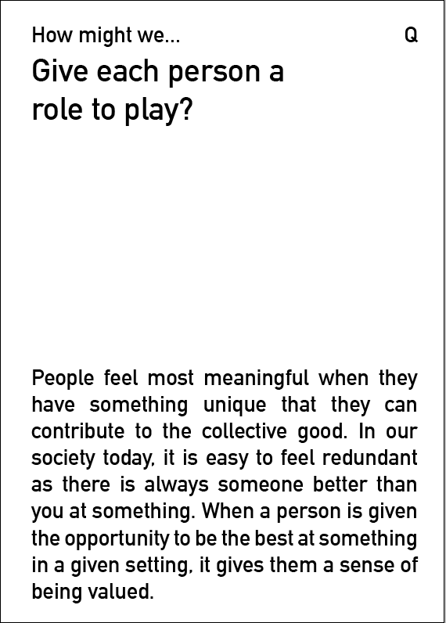  

**List of cards**

|  |  |  |
| --- | --- | --- |
| **Nostalgia design principle** | **Context** | **Medium** |
| Build in challenge and anticipation | Dating | Object |
| Create a group ritual | Eating | App |
| Help people stay in the present | Receiving healthcare | Environment |
| Give people a regular sense of accomplishment | Sports and exercise | Service |
| Chunk the experience | Cleaning and laundry | Event |
| Create opportunities to share a prized resource | Doing taxes | Immersive experience |
| Impose constraints to spark creativity | Shopping | Toy / game |
| Give each person a role to play | Birthdays | Kit |
| Induce a state of focus | Taking a shower | Device |
| Inspire a sense of wonder | Driving and sitting in traffic | Ritual |

# Bibliography

Amato, P. R. (1983). The effects of urbanization on interpersonal behavior. *Journal of Cross-Cultural Psychology, 14*, 353-367.

American Psychological Association. (2015). *Former APA Presidents*. Retrieved November 16, 2016, from American Psychological Association: http://www.apa.org/about/governance/president/past-presidents.aspx

Andersen, I., Thielen, K., Per, B., Nygaard, E., & Diderichsen, F. (2011, September 29). Increasing prevalence of depression from 2000 to 2006. *Scadinavian Journal of Public Health, 39*(8), 857-863.

Beck, U., Giddens, A., & Lash, S. (1994). *Reflexive modernization.* Stanford University Press.

Bensman, J., & Lilienfield, R. (1979). *Between public and private.* New York: Free Press.

Benz, P. (2014). *Experience Design: Concepts and Case Studies.* Bloomsbury Publishing.

Bianchi, L., Dorigo, M., Gambardella, L. M., & Gutjahr, W. J. (2009). A survey on metaheuristics for stochastic combinatorial optimization. *Natural Computing: an international journal, 8*(2), 239–287.

Biller, O. (1977). Suicide related to the assassination of President John F. Kennedy. *Suicide and Life Threatening Behaviour, 7*, 40-44.

Bornstein, M. H. (1979, March 12). The pace of life: revisited. *International journal of psychology*.

Bornstein, M. H., & Bornstein, H. (1976, February 19). The pace of life. *Nature, 259*, 557 - 559.

Boym, S. (2002). *The Future of Nostalgia.* Basic Books.

Brown, S. (1999). Retro‐marketing: yesterday’s tomorrows, today! *Journal of Marketing Practice: Applied Marketing Science, 17*(7), 363 - 376.

Brownstein, R. (2016, June 2). *Trump's Rhetoric of White Nostalgia*. Retrieved from The Atlantic: http://www.theatlantic.com/politics/archive/2016/06/trumps-rhetoric-of-white-nostalgia/485192/

Bruni, L., & Stanca, L. (2006, April 21). Income Aspirations, Television and Happiness: Evidence from the World Values Survey. *International Review for Social Sciences, 59*(2), 209–225.

Buss. (2000). The evolution of happiness. *American psychologist, 55*(1), 15.

Cacioppo, J. T., & Patrick, W. (2008). *Loneliness: Human Nature and the Need for Social Connection.* W. W. Norton & Company.

Cameron, C., & Gatewood, J. (1994). The authentic interior: questing gemeinschaft in post-industrial society. *Human Organization, 53*(1), 21-32.

Canadian Index of Well Being. (2016). *Domains and Indicators*. Retrieved November 12, 2016, from Canadian Index of Well Being: https://uwaterloo.ca/canadian-index-wellbeing/what-we-do/domains-and-indicators/percentage-15-64-year-olds-reporting-high-levels-time

Candy, S. (2014, March 20). *The Thing From The Future*. Retrieved from Situation Lab: http://situationlab.org/projects/the-thing-from-the-future/

Carlin, G. (1998). *Brain Droppings.* Hyperion Books.

Centre for Addiction and Mental Health. (2015, June). Association between daily use of social media and mental health among students in Ontario. *Population Studies eBulletin, 16*(2).

Centre for Addiction and Mental Health. (2016, February 2). *Emergency visits by Ontario youth for mental health, addiction increase by 32 per cent over six years*. Retrieved October 21, 2016, from Centre for Addiction and Mental Health: http://www.camh.ca/en/hospital/about_camh/newsroom/news_releases_media_advisories_and_backgrounders/current_year/Pages/Emergency-visits-by-Ontario-youth-for-mental-health-addiction-increase-by-32-per-cent-over-six-years.aspx

Chilton, S. (2002). Personal conversation. (J. L. Wilson, Interviewer)

Cutler, D. M., Glaeser, E. L., & Norberg, K. E. (2001). Explaining the Rise in Youth Suicide. In J. Gruber, *Risky Behavior among Youths: An Economic Analysis* (pp. 219-270). University of Chicago Press.

DeVoe, S. E., & House, J. (2012). Time, money, and happiness: How does putting a price on time affect our ability to smell the roses? *Journal of Experimental Social Psychology, 48*(2), 466-474.

Durkheim, E. (1897). *Le Suicide* (English translation, 1951 ed.). Glencoe: Free Press.

Egeland, J., & Hostetter, A. (1983, January). Amish Study, I: Affective disorders among the Amish, 1976-1980. *The American Journal of Psychiatry, 140*(1), 56-61.

Fritz, C. (1996). *Historical and Comparative Disaster Series #10: Disasters and Mental Health: Therapeutic Principles Drawn from Disaster Studies.* University of Delaware Disaster Research Center.

Geert Hofstede. (2016). *Canada*. Retrieved from Geert Hofstede: https://geert-hofstede.com/canada.html

Giddens, A. (2013). *Modernity and Self-Identity: Self and Society in the Late Modern Age.* John Wiley & Sons.

Gray, P. (2009). Play as a Foundation for Hunter- Gatherer Social Existence. *American Journal of Play*, 476 –522.

Haggbloom, S. J., Warnick, J. E., Jones, V. K., Yarbrough, G. L., Russell, T. M., Borecky, C. M., . . . al., e. (2002). The 100 most eminent psychologists of the 20th century. *Review of General Psychology, 6*(2), 139–152.

Hagnell, O. (1989). Repeated incidence and prevalence studies of mental disorders in a total population followed during 25 years. *The Lundby Study, 79*(S348), 61-77.

Hagnell, O., L, O., Otterbeck, L., & Rorsman, B. (1994). Prevalence of mental disorders, personality traits and mental complaints in the Lundby Study. A point prevalence study of the 1957 Lundby cohort of 2,612 inhabitants of a geographically defined area who were re-examined in 1972 regardless of domicile. *Acta Psychiatrica Scandinavica, 79*(S348), 1–77.

Hassenzahl, M. (2010). *Experience Design: Technology for All the Right Reasons,.* Morgan & Claypool Publishers.

Hawton, K., Harriss, L., Appleby, L., & al, e. (2000). Effect of death of Diana, Princess of Wales on suicide and deliberate self-harm. *British Journal of Psychiatry, 177*, 463-466.

Helliwell, J., Layard, R., & Sachs, J. (2013). *World Happiness Report 2013.*

Hidaka, B. H. (2012). Depression as a disease of modernity: explanations for increasing prevalence. *Journal of Affective Disorders, 140*(3), 205–214.

Hirsch, A. (1992). Nostalgia: a Neuropsychiatric Understanding. *Advances in Consumer Research, 19*, 390-395.

Hollan, D., & Wellenkamp, J. (1994). *Contentment and suffering: Culture and experience in Toraja.* Columbia University Press.

Johnson-Weiner, K. M. (2006). *Train Up a Child.* Johns Hopkins University Press.

Jones, R. P., Cox, D., Cooper, B., & Lienesch, R. (2016). *Findings from the 2016 American Values Survey.* Public Religion Research Institute (PRRI), Washington DC. Retrieved from Robert P. Jones, Daniel Cox, Betsy Cooper, and Rachel Lienesch: http://www.prri.org/wp-content/uploads/2016/10/PRRI-2016-American-Values-Survey.pdf

Junger, S. (2016). *Tribe: On Homecoming and Belonging.*

Kelly, R. L. (1995). *The Foraging Spectrum: Diversity in Hunter-Gatherer Lifeways (1995), 302–3.* Smithsonian Institution Press.

Korunka, C., & Hoonakker, P. (2014). *The Impact of ICT on Quality of Working Life.* Springer Science & Business.

Kraut, R., Lundmark, V., Patterson, M., Kiesler, S., Mukopadhyay, T., & Scherlis, W. (1998, September). Internet Paradox: A Social Technology That Reduces Social Involvement and Psychological Well-Being? . *American Psychologist, 53*(9), 1998.

Kraybill, D. B. (2001). *The Riddle of Amish Culture.* Johns Hopkins University Press.

Kross, E., Verduyn, P., Demiralp, E., Park, J., Lee, D. S., Natalie Lin, S. H., . . . Ybarra, O. (2013, August 14). Facebook Use Predicts Declines in Subjective Well-Being in Young Adults. *PLoS One, 8*(8).

Kuhn, P., Lozano, & Fernando. (2005). *The expanding workweek? understanding trends in long work hours among US men, 1979-2004.* National Bureau of Economic Research.

Lane, R. E. (2000). *The Loss of Happiness in Market Democracies.* New Haven: Yale University Press.

Lasaleta, J. D., Sedikides, C., & Vohs, K. D. (2014, October 1). Nostalgia Weakens the Desire for Money. *Journal of Consumer Research*, 713-729.

Leberecht, T. (2013, May 13). *Back to the future: why retro-innovation is the next big thing*. Retrieved from Fast Company: https://www.fastcodesign.com/1672508/back-to-the-future-why-retro-innovation-is-the-next-big-thing

Leberecht, T. (2015). *The Business Romantic: Give Everything, Quantify Nothing, and Create Something Greater Than Yourself.* Harper Collins.

Lee, R. (1988). Reflections on primitive communism. In T. Ingold, D. C. Riches, & J. C. Woodburn, *Hunters and Gatherers: History, Evolution, and Culture Change* (pp. 252-268). Oxford.

Lee, S., Tsang, A., Zhang, M., Huang, Y., He, Y., Liu, Z., . . . Kessler, R. (2007). Lifetime prevalence and inter-cohort variation in DSM-IV disorders in metropolitan China. *Psychological Medicine, 37*(1), 61-77.

Leibbrandt, A., Gneezy, U., & Listd, J. A. (2013, June 4). Rise and fall of competitiveness in individualistic and collectivistic societies. *Economic Sciences, 110*(23), 9305–9308.

Lester, D. (1995). Suicide rates before and after the world wars. European Psychiatry, 9, 262–264. *European Psychiatry, 9*, 262–264.

Levine, R. (2008). *A Geography Of Time: On Tempo, Culture, And The Pace Of Life.* Basic Books.

Levine, R. V. (1999). The Pace of Life in 31 Countries. *Journal of cross cultural psychology, 30*(2), 178-205.

Lifeboat. (2013). *The state of friendship in America 2013: A crisis of confidence.*

Lin, L., Sidani, J., Shensa, A., Radovic, A., Miller, E., Colditz, J., . . . Primack, B. (2016, April). Association between Social Media Use and Depression among U.S. Young Adults. *Depression and Anxiety, 33*(4), 323-331.

Lowenthal, D. (1985). *The past is a foreign country.* Cambridge University Press.

Lyons, H. A. (1971). Psychiatric sequelae of the Belfast riots. *The British Journal of Psychiatry, 118*(544), 265-273.

Mangen, A., Walgermo, B. R., & Brønnick, K. (2013). Reading linear texts on paper versus computer screen: Effects on reading comprehension. *International Journal of Educational Research, 58*(2013), 61-68.

Marche, S. (2012, May). *Is Facebook Making Us Lonely?* Retrieved from The Atlantic: http://www.theatlantic.com/magazine/archive/2012/05/is-facebook-making-us-lonely/308930/

Marzano, S. (2003). *The New Everyday: Views on Ambient Intelligence.* 010 Publishers.

McPherson, M., Smith-Lovin, L., & Brashears, M. E. (2006, June). Social Isolation in America: Changes in Core Discussion Networks over Two Decades. *American Sociological Review, 71*(3), 353-375.

Meuhling, D. D., & Sprott, D. E. (2014). Exploring the Boundaries of Nostalgic Advertising Effects: A Consideration of Childhood Brand Exposure and Attachment on Consumers’ Responses to Nostalgia-Themed Advertisements. *Journal of Advertising, 43*(1), 73-84.

Mojtabai, R. (2013). Clinician-identified depression in community settings: concordance with structured-interview diagnoses. *Psychother Psychosom, 82*(3), 161-9.

Muehling, D. D., Sprott, D. E., & Sultan, A. J. (2014). Exploring the Boundaries of Nostalgic Advertising Effects: A Consideration of Childhood Brand Exposure and Attachment on Consumers’ Responses to Nostalgia-Themed Advertisements. *Journal of Advertising, 43*(1), 73-84.

Nesse, R. M., & Williams, G. C. (1994). *Why We Get Sick: The New Science of Darwinian Medicine.* Times Books.

Perlman, D., & Peplau, L. A. (1981). Toward a Social Psychology of Loneliness. In S. Duck, & R. Gilmour, *Personal Relationships: Personal relationships in disorder.* Academic Press.

Perrin, A. (2015, December 8). *One-fifth of Americans report going online ‘almost constantly’*. Retrieved from Pew Research Center: http://www.pewresearch.org/fact-tank/2015/12/08/one-fifth-of-americans-report-going-online-almost-constantly/

Pickett, K., & Wilkinson, R. (2010). *The Spirit Level: Why Equality is Better for Everyone.* Penguin Books Limited.

Piketty, T. (2013). *Capital in the Twenty-First Century.* Harvard University Press.

Przybylski, A. K., & Weinstein, N. (2013, May). Can you connect with me now? How the presence of mobile communication technology influences face-to-face conversation quality. *Journal of Social and Personal Relationships, 30*(3), 237-246.

Renzetti, E. (2013, November 23). *Life of solitude: A loneliness crisis is looming*. Retrieved from The Globe and Mail: http://www.theglobeandmail.com/life/life-of-solitude-a-loneliness-crisis-is-looming/article15573187/%7B%7Burl%7D%7D/?reqid=%257B%257Brequest_id%257D%257D

Robinson, J., & Godbey, G. (1999). *Time for life: the surprising ways Americans use their time.* University Park: Pennsylvania State University Press.

Rockmann, K. W., & Northcraft, G. B. (2008). To be or not to be trusted: The influence of media richness on defection and deception. *Kevin W. Rockmann a,*, Gregory B. Northcraft b,1, 107*, 106-122.

Rosa, H. (2010). *High-speed Society: Social Acceleration, Power, and Modernity.* Penn State Press.

Routledge, C. W., Sedikides, C., Hart, C. M., Vingerhoets, A. J., Arndt, J., Juhl, J., & Schlotz, W. (2011). The Past Makes the Present Meaningful: Nostalgia as an Existential Resource. *Journal of Personality and Social Psychology, 101*(3), 638 – 652.

Roxburgh, S. (2004, June). ‘There Just Aren’t Enough Hours in the Day’: The Mental Health Consequences of Time Pressure. *Journal of Health and Social Behavior, 45*, 115–131.

Salid, E. (2003, August). Effect of 11 September 2001 on suicide and homicide in England and Wales. *he British Journal of Psychiatry, 183*(3), 207-212.

Schwartz, B. (2009). *The Paradox of Choice: Why More Is Less* (Revised Edition ed.). Harper Collins.

Seligman, M. P. (1990). Why Is There So Much Depression Today? The Waxing of the Individual and the Waning of the Commons. In R. E. Ingram, *Contemporary Psychological Approaches to Depression: Theory, Research, and Treatment* (pp. 1-9). Springer US.

Shedroff, N. (2001). *Experience Design 1.* Thousand Oaks: New Riders Publishing.

Shephard, R., & Rode, A. (1996). *The Consequences of ‘modernization:’ Evidence from circumpolar peoples.* Cambridge University Press.

Slater, P. (1970). *The Pursuit of Loneliness: America's Discontent and the Search for a New Democratic Ideal.* Beacon Press.

Smith, K. (2000). Mere Nostalgia: Notes on a progressive paratheory. *Rhetoric and Public Affairs, 3*(4), 505-527.

Stevens, A., & Price, J. (2000). *Evolutionary Psychiatry: A New Beginning.* London: Routledge.

Stutzer, A. (2004). The role of income aspirations in individual happiness. *Journal of Economic Behavior & Organization, 54*(1), 89-109.

The Economist. (2011, June 30). *Too much information*. Retrieved from The Economist: http://www.economist.com/node/18895468

The Economist. (2014, December 20). *Why is everyone so busy? Time poverty is a problem partly of perception and partly of distribution*. Retrieved from The Economist: http://www.economist.com/news/christmas-specials/21636612-time-poverty-problem-partly-perception-and-partly-distribution-why

Tooby, J., & Cosmides, L. (1996). Friendship and the Banker's Paradox: Other Pathways to the Evolution of Adaptations for Altruism. *Proceedings of the British Academy 88*, (pp. 119-143).

Trollinger, S. (2012). *Selling the Amish: The Tourism of Nostalgia.* Johns Hopkins University Press.

Trollinger, S. (2016, October 3). Interview. (G. Wang, Interviewer)

Twenge, J. M. (2015). Time Period and Birth Cohort Differences in Depressive Symptoms in the U.S., 1982–2013. *Social Indicators Research, 121*(2), 437–454.

Umble, D. Z. (2000). *Holding the Line.* Johns Hopkins Univerisity Press.

Varty, B. (2016, June 10). *What Wisdom Can We Gain From Nature?* Retrieved from NPR TED Radio Hour: http://www.npr.org/2016/06/10/481294968/what-wisdom-can-we-gain-from-nature

Vega, W., Sribney, W., Aguilar-Gaxiola, S., & Kolody, B. (2004). psychiatric disorders among Mexican Americans: nativity, social assimilation, and age determinants. *The Journal of nervous and mental disease, 192*(8), 532-541.

Wagner, P. (1994). *A Sociology of Modernity: Liberty and Discipline.* Routledge.

Wajcman, J. (2014). *Pressed for Time: The Acceleration of Life in Digital Capitalism.* University of Chicago Press.

Weaver, G. R. (1999). American Cultural Values. *Kokusai bunka kenshu (intercultural training)*, 9-15.

Weissner, P. (1996). Leveling the hunter: constraints on the status quest in foraging societies. In P. W. Wiessner, P. Wiessner, & W. Schiefenhövel, *Food and the Status Quest: An Interdisciplinary Perspective* (pp. 171-191). Providence: Berghahn Books.

Wildschut, T., Sedikides, C., Arndt, J., & Routledge, C. (2006). Nostalgia: Content, Triggers, Functions. *Journal of Personality and Social Psychology, 91*(5), 975–993.

Wilson, J. L. (2005). *Nostalgia: Sanctuary of Meaning.* Bucknell University Press.

Wiseman, R. (2007, March 25). *International Experiment Proves Pace of Life is Speeding up by 10%*. Retrieved from Pace of Life: http://www.richardwiseman.com/resources/Pace%20of%20LifePR.pdf

Wood, G. (2011, April). *Secret Fears of the Super-Rich* . Retrieved from The Atlantic: http://www.theatlantic.com/magazine/archive/2011/04/secret-fears-of-the-super-rich/308419/

Wurman, R. S. (1989). *Information Anxiety.* Doubleday.

Xue, H., & Wooley, M. (2011). Nostalgia and Its Value to Design Strategy. *Proceedings of Tsinghua-DMI International Design Management Symposium 2011.* Hong Kong.

Xue, H., & Wooley, M. (2011). The Charm of Memory: examining nostalgic experience from a design perspective. *Proceedings of the 4th World Conference on Design Research (IASDR 2011).* Delft.

Xue, H., & Wooley, M. (2013). Creatively Designing with/for Cultural Nostalgia: Designers' Reflections on Technological Change and Loss of Physicality. *IASDR 2013 Conference proceedings.* Tokyo.

Zhou, X., Sedikides, C., Wildschut, T., & Gao, D.-G. (2008). Counteracting Loneliness: On the Restorative Function of Nostalgia. *Psychological Science, 19*(10), 1023-1029.